
 | VIỆN ĐÀO TẠO QUỐC TẾ FPT  DATA SCIENCE WITH AI-ML |   

AI Job Market Salary Prediction
Technical Specification Design - Semester II
Lecturer: Ms. Nguyen Ha Vy
Course: I1.2510.E0
Group: 03
Member: | Full Name |  | Student ID
 | 1. | Huỳnh Nhật Minh | FIS00012
 | 2. | Tạ Gia Hiển | FIS00002
 | 3. | Hoàng Đức Duy | FIS00004
 | 4. | Nguyễn Kim Ngân | FIS00010
- September 2026 -

TABLE OF CONTENTS
A - PROJECT INTRODUCTION 3
A.1. Project Scope 3
A.2. Pipeline Overview 4
A.3. Limitations of the Project 4
B - SYSTEM ARCHITECTURE & TECHNICAL REQUIREMENTS 5
B.1. Hardware and Infrastructure Requirements 5
B.2. Software Environment 5
B.3. Technology Stack 5
C. DESIGN PROCESS 6
STAGE 1. Project Scope & Raw Data Ingestion 6
STAGE 2. Basic Clean 8
STAGE 3. Contradictory-Feature Investigation (Điều tra đặc trưng mâu thuẫn) 9
STAGE 4. Feature Importance & Leakage Prevention 12
STAGE 5. Feature Selection 13
BRANCH A. AI Job Market Segmentation (Unsupervised Learning) 14
BRANCH B. Salary Prediction (Supervised Learning) 18
STAGE B1-2-3. Train-Test Split 18
STAGE B4. Model Training & Comparison 20
STAGE B5-6. Best Model Selection 26
STAGE B7. Save Deployable Pipeline + Metadata 30
STREAMLIT. Salary Prediction Dashboard 33
D – INSTALLATION & HOW TO RUN THE PROJECT 38
E - CONCLUSION AND FUTURE DEVELOPMENT 41
F - REFERENCES 56
G - TASK ASSIGNMENT TABLE 56

A - PROJECT INTRODUCTION

A.1. Project Scope
1.1. Project Overview:
This project focuses on AI Job Market Data Cleaning, Exploratory Data Analysis, and Salary Prediction Modelling, demonstrating a careful, skeptical approach to validating a dataset before trusting it for machine learning.
1.2. Expected Outcomes:
A systematic data-quality-first cleaning and modelling framework is required to convert raw job postings into a clean, trustworthy, and deployable salary-prediction pipeline.
Regression models are trained and compared.
The best model is packaged as a deployable artifact, and an interactive Streamlit dashboard is built to predict AI job salaries in real time.
1.3. Problem Statement:
The job-market dataset presents several challenges:
Area | Status | Observed evidence | Assessment
Data mechanics | GREEN | + 0 missing;  + 0 duplicate;  + 1 corrupted row removed (job_catergory);  + 1 identifier (job_id),  + 7 derived flags. | => Basic clean
Semantic integrity | RED | + 74.25% experience mismatch (experience_level and years_of_experience);  + 72.44% salary-tier mismatch;  + 40.80% salary-range mismatch (salary_min_usd, salary_max_usd). | + Contradictory (same concept but disagree)/redundant  + Target leakage  => Leakage governance
Temporal validation | GREEN | + March-2026 locked test;  + 5 expanding temporal folds. | Good
Feature plausibility | RED | Top-2 encoded importance = 86.6%;  years_of_experience & job_catergory signal are directionally implausible. | Residuals analysis  => dataset is simple?
- Lock 22 features.
- Allowed 2 features and 1 target.

A.2. Pipeline Overview
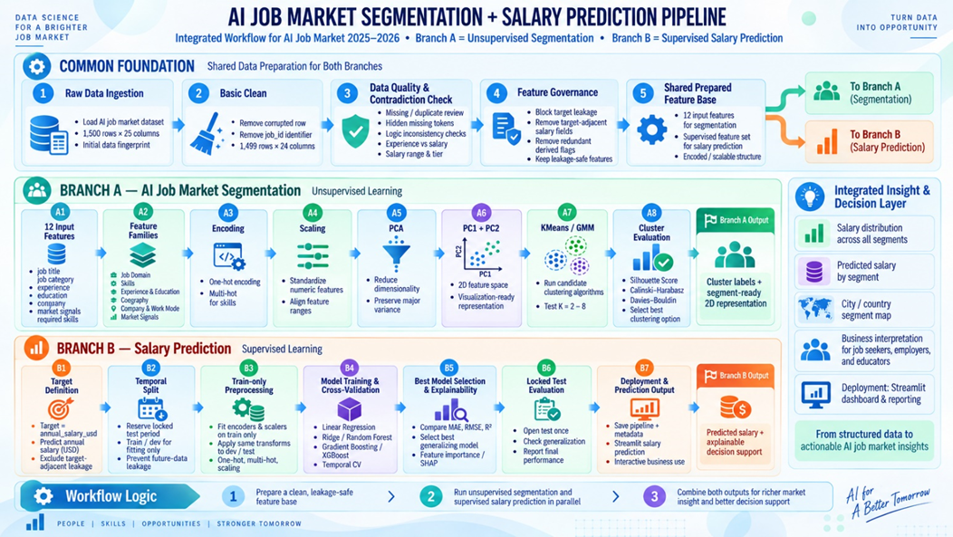

A.3. Limitations of the Project
- The pipeline runs successfully and manages leakage quite well, but the data shows strong signs of being synthetic or containing heavy logical artifacts. The model performs well according to statistical metrics, yet most of its predictive power comes from job_category and years_of_experience — two signals that appear to be “embedded” in the data structure itself. Therefore, the results are suitable for academic exercises or ML system demonstrations, but they do not provide sufficient evidence to interpret as real-world labor economics.

B - SYSTEM ARCHITECTURE & TECHNICAL REQUIREMENTS

B.1. Hardware and Infrastructure Requirements
Component | Specification | Notes
Processing Power (CPU) | Modern multi core CPU (Intel Core i3/i5 or AMD Ryzen equivalent) | Dataset is small (~1,500 rows); no GPU or deep learning hardware required.
Memory (RAM) | Minimum 4GB, recommended 8GB | Enough to load data with Pandas, perform feature engineering, and train Random Forest models.
Storage | < 500MB free disk space | Covers source code, dataset, PNG visualizations, and .joblib model artifacts.
Infrastructure | Local machine execution | No need for distributed systems (Spark) or cloud GPU instances.

B.2. Software Environment
Component | Specification | Notes
Operating System | Windows, macOS, or Linux | Fully cross-platform; no OS-specific dependencies.
Programming Language | Python 3.10+ | Required for modern syntax features such as type hinting and updated dictionary methods.
Environment Isolation | Virtual environment recommended (venv, virtualenv, conda) | Prevents dependency conflicts with system-level Python packages and ensures reproducible builds.

B.3. Technology Stack
Using Python libraries such as Pandas, NumPy, Matplotlib, and Scikit-learn.
Tool / Technology | Purpose
Python | Core programming language
Pandas | Data loading and manipulation
NumPy | Numerical computations
Matplotlib | Data visualization
Scikit-learn | Preprocessing pipelines, models, evaluation metrics
Joblib | Saving and loading the trained pipeline artifacts
CSV Dataset | Data storage (ai_jobs_market_2025_2026.csv)
Jupyter Notebook | EDA & model development
Streamlit | Interactive salary-prediction dashboard

C. DESIGN PROCESS
Overall | Full Pipeline  The technical design is implemented as a reproducible sequence from raw ingestion to Streamlit inference.

STAGE 1. Project Scope & Raw Data Ingestion
- Question & expectation: This project focuses on AI Job Market Data Cleaning, Exploratory Data Analysis, and Salary Prediction Modelling, demonstrating a careful, skeptical approach to validating a dataset before trusting it for machine learning - AI Job Market Salary Prediction.
- Formal Task Definition:
Component | Definition
Task type | Unsupervised AI Job Market Segmentation and Supervised Prediction
Target y | annual_salary_usd, integer USD/year
Input X | Only features known at prediction time and admitted by feature policy
Prediction moment | Before annual_salary_usd is known/finalized
Primary output | Predicted annual salary in USD
Primary intended user | Analyst / student / decision-support user exploring salary benchmarks

- Data Profiling:
Column | dtype | Unique | Unique % | Missing | Hidden miss. | Metric comment
job_id | str | 1500 | 100.0% | 0 | 0 | 100% unique → identifier, block from X
job_title | str | 25 | 1.7% | 0 | 0
AI Engineering | str | 13 | 0.9% | 0 | 0 | 1 invalid header token detected, rename to job_catergory
experience_level | str | 4 | 0.3% | 0 | 0
years_of_experience | int64 | 15 | 1.0% | 0 | 0
education_required | str | 5 | 0.3% | 0 | 0
annual_salary_usd | int64 | 248 | 16.5% | 0 | 0
salary_min_usd | int64 | 17 | 1.1% | 0 | 0 | target-adjacent → leakage risk
salary_max_usd | int64 | 16 | 1.1% | 0 | 0 | target-adjacent → leakage risk
city | str | 20 | 1.3% | 0 | 0
country | str | 14 | 0.9% | 0 | 0
remote_work | str | 3 | 0.2% | 0 | 0
company_size | str | 5 | 0.3% | 0 | 0
industry | str | 12 | 0.8% | 0 | 0
required_skills | str | 1500 | 100.0% | 0 | 0 | 100% raw-string unique → tokenize/multi-hot needed
ai_salary_premium_pct | float64 | 151 | 10.1% | 0 | 0
demand_score | int64 | 20 | 1.3% | 0 | 0
demand_growth_yoy_pct | float64 | 565 | 37.7% | 0 | 0
benefits_score_10 | int64 | 5 | 0.3% | 0 | 0
posting_year | int64 | 2 | 0.1% | 0 | 0
posting_month | int64 | 12 | 0.8% | 0 | 0
is_senior | int64 | 2 | 0.1% | 0 | 0
is_remote_friendly | int64 | 2 | 0.1% | 0 | 0
is_llm_role | int64 | 2 | 0.1% | 0 | 0
salary_tier | str | 5 | 0.3% | 0 | 0 | target-adjacent → leakage risk

- Target Distribution:
- annual_salary_usd ranges from $90,000 to $384,000;
- mean = $194,892;
- median = $180,000;
- standard deviation = $66,507.
- The IQR rule flags 8 high-end values above $373,500; these are not automatically removed because salary extremes can be legitimate. Outlier handling must be evidence-based and fit on TRAIN only.

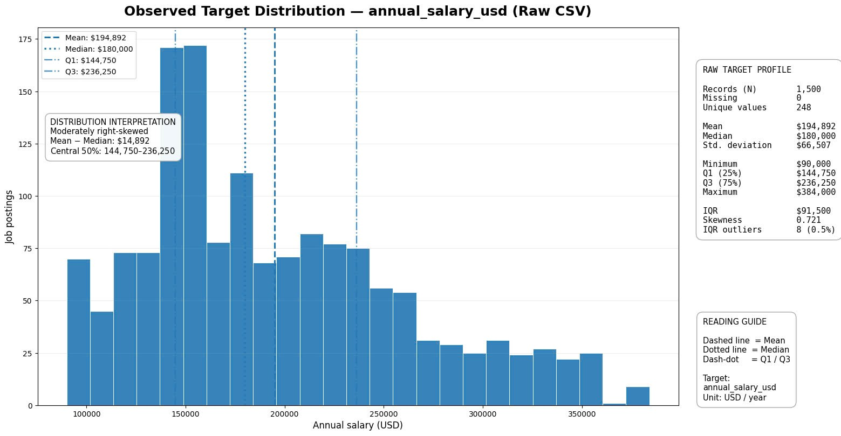Figure 1. salary target distribution from the raw CSV.

Numeric feature | Mean | SD | Min | Q1 | Median | Q3 | Max
years_of_experience | 6.22 | 2.68 | 1.00 | 4.00 | 6.00 | 8.00 | 15.00
annual_salary_usd | 194,892.00 | 66,506.82 | 90,000.00 | 144,750.00 | 180,000.00 | 236,250.00 | 384,000.00
salary_min_usd | 135,448.67 | 24,448.95 | 90,000.00 | 120,000.00 | 140,000.00 | 155,000.00 | 180,000.00
salary_max_usd | 257,537.33 | 39,852.82 | 180,000.00 | 218,000.00 | 270,000.00 | 290,000.00 | 320,000.00
ai_salary_premium_pct | 10.86 | 4.03 | 3.00 | 8.20 | 10.50 | 14.20 | 18.00
demand_score | 87.52 | 8.03 | 68.00 | 82.00 | 89.00 | 95.00 | 98.00
demand_growth_yoy_pct | 31.12 | 22.05 | 5.00 | 15.38 | 23.40 | 42.70 | 87.80
benefits_score_10 | 7.96 | 1.18 | 6.00 | 7.00 | 8.00 | 9.00 | 10.00
posting_year | 2,025.58 | 0.49 | 2,025.00 | 2,025.00 | 2,026.00 | 2,026.00 | 2,026.00
posting_month | 3.97 | 3.27 | 1.00 | 2.00 | 3.00 | 5.00 | 12.00
is_senior | 0.50 | 0.50 | 0.00 | 0.00 | 0.00 | 1.00 | 1.00
is_remote_friendly | 0.75 | 0.43 | 0.00 | 1.00 | 1.00 | 1.00 | 1.00
is_llm_role | 0.22 | 0.41 | 0.00 | 0.00 | 0.00 | 0.00 | 1.00

STAGE 2. Basic Clean

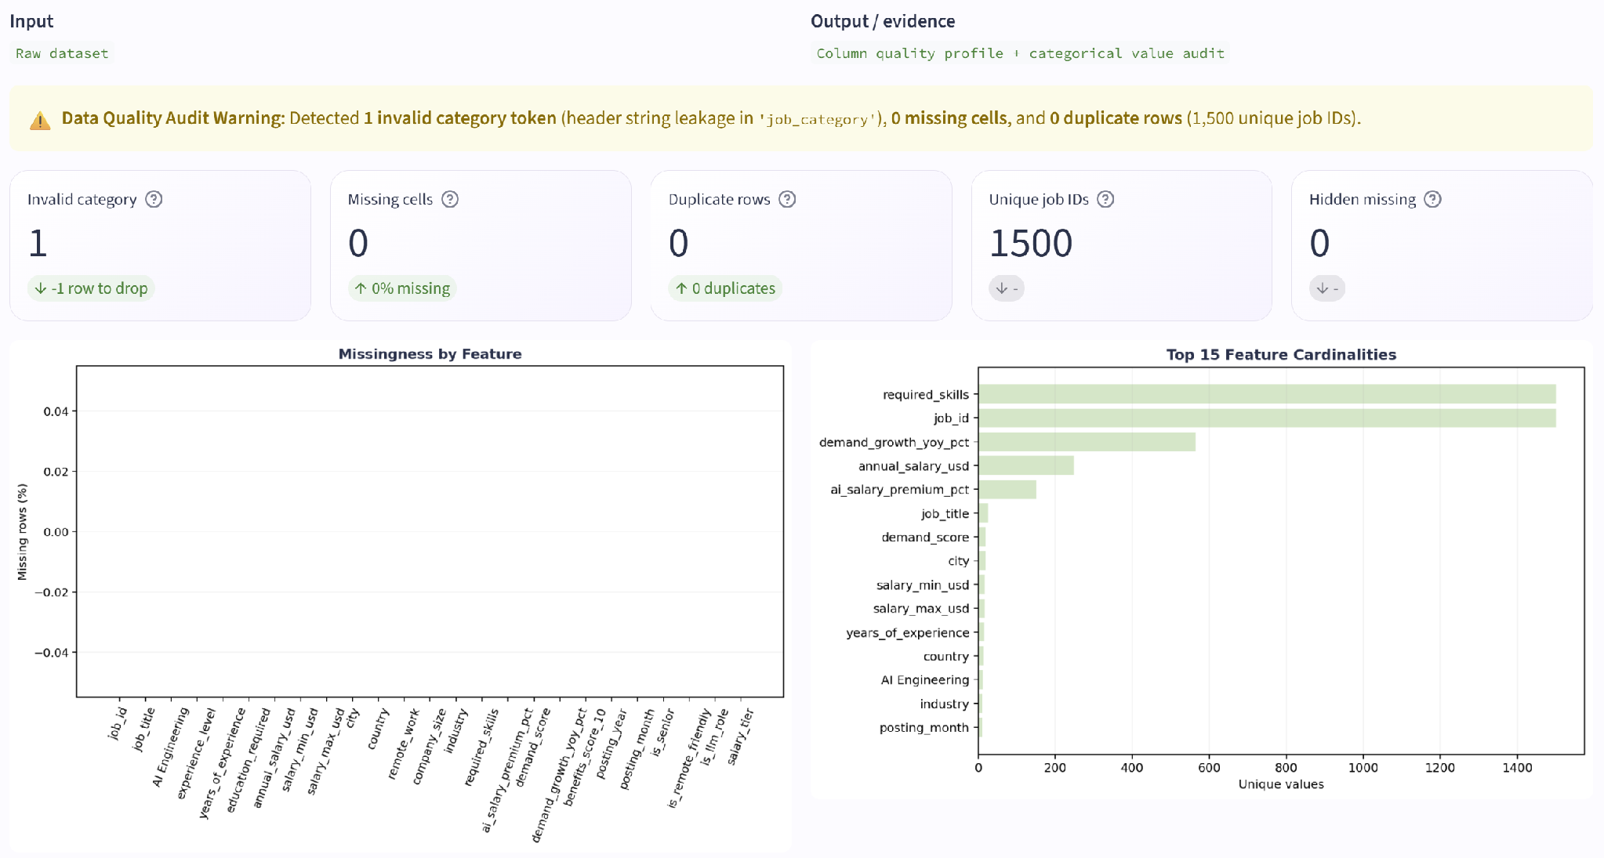
Figure 2. data quality from the raw CSV.

- The AI Engineering column contained a value of "job_category" (count = 1, job_id AIJOB1205) — the column header itself had leaked into the data as a row value:
Issue | Observed evidence | Magnitude | Required action
Categorical corruption | AI Engineering contains literal value "job_category" for AIJOB1205. | 1 / 1,500 | Remove row; do not impute an invented domain.

Impact Assessment: Removing the corrupted row (AIJOB1205 containing the header string "job_category") eliminates categorical string pollution in the job_category feature, preventing invalid dummy columns during encoding while maintaining complete data integrity with 1,499 valid rows remaining.
Outlier Policy: The 8 upper-tail salary values above the $373,500 IQR threshold are preserved as valid domain extremes (e.g., senior executive/principal AI roles) to maintain true target variance. Any scaling or robust transformation is strictly fitted on cross-validation training folds to prevent look-ahead bias.

STAGE 3. Contradictory-Feature Investigation (Điều tra đặc trưng mâu thuẫn)
- To investigate contradictory features tell a consistent story before trusting either of them.

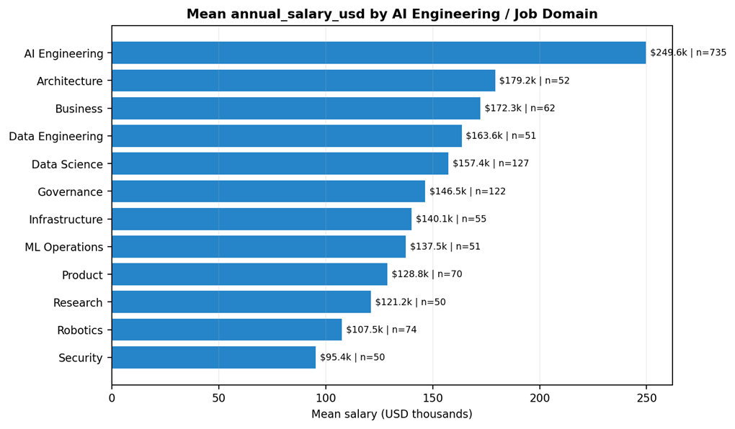
Figure 3a. mean salary by source job-domain field; the dominant domain-level separation is a synthetic-risk signal, not causal proof.

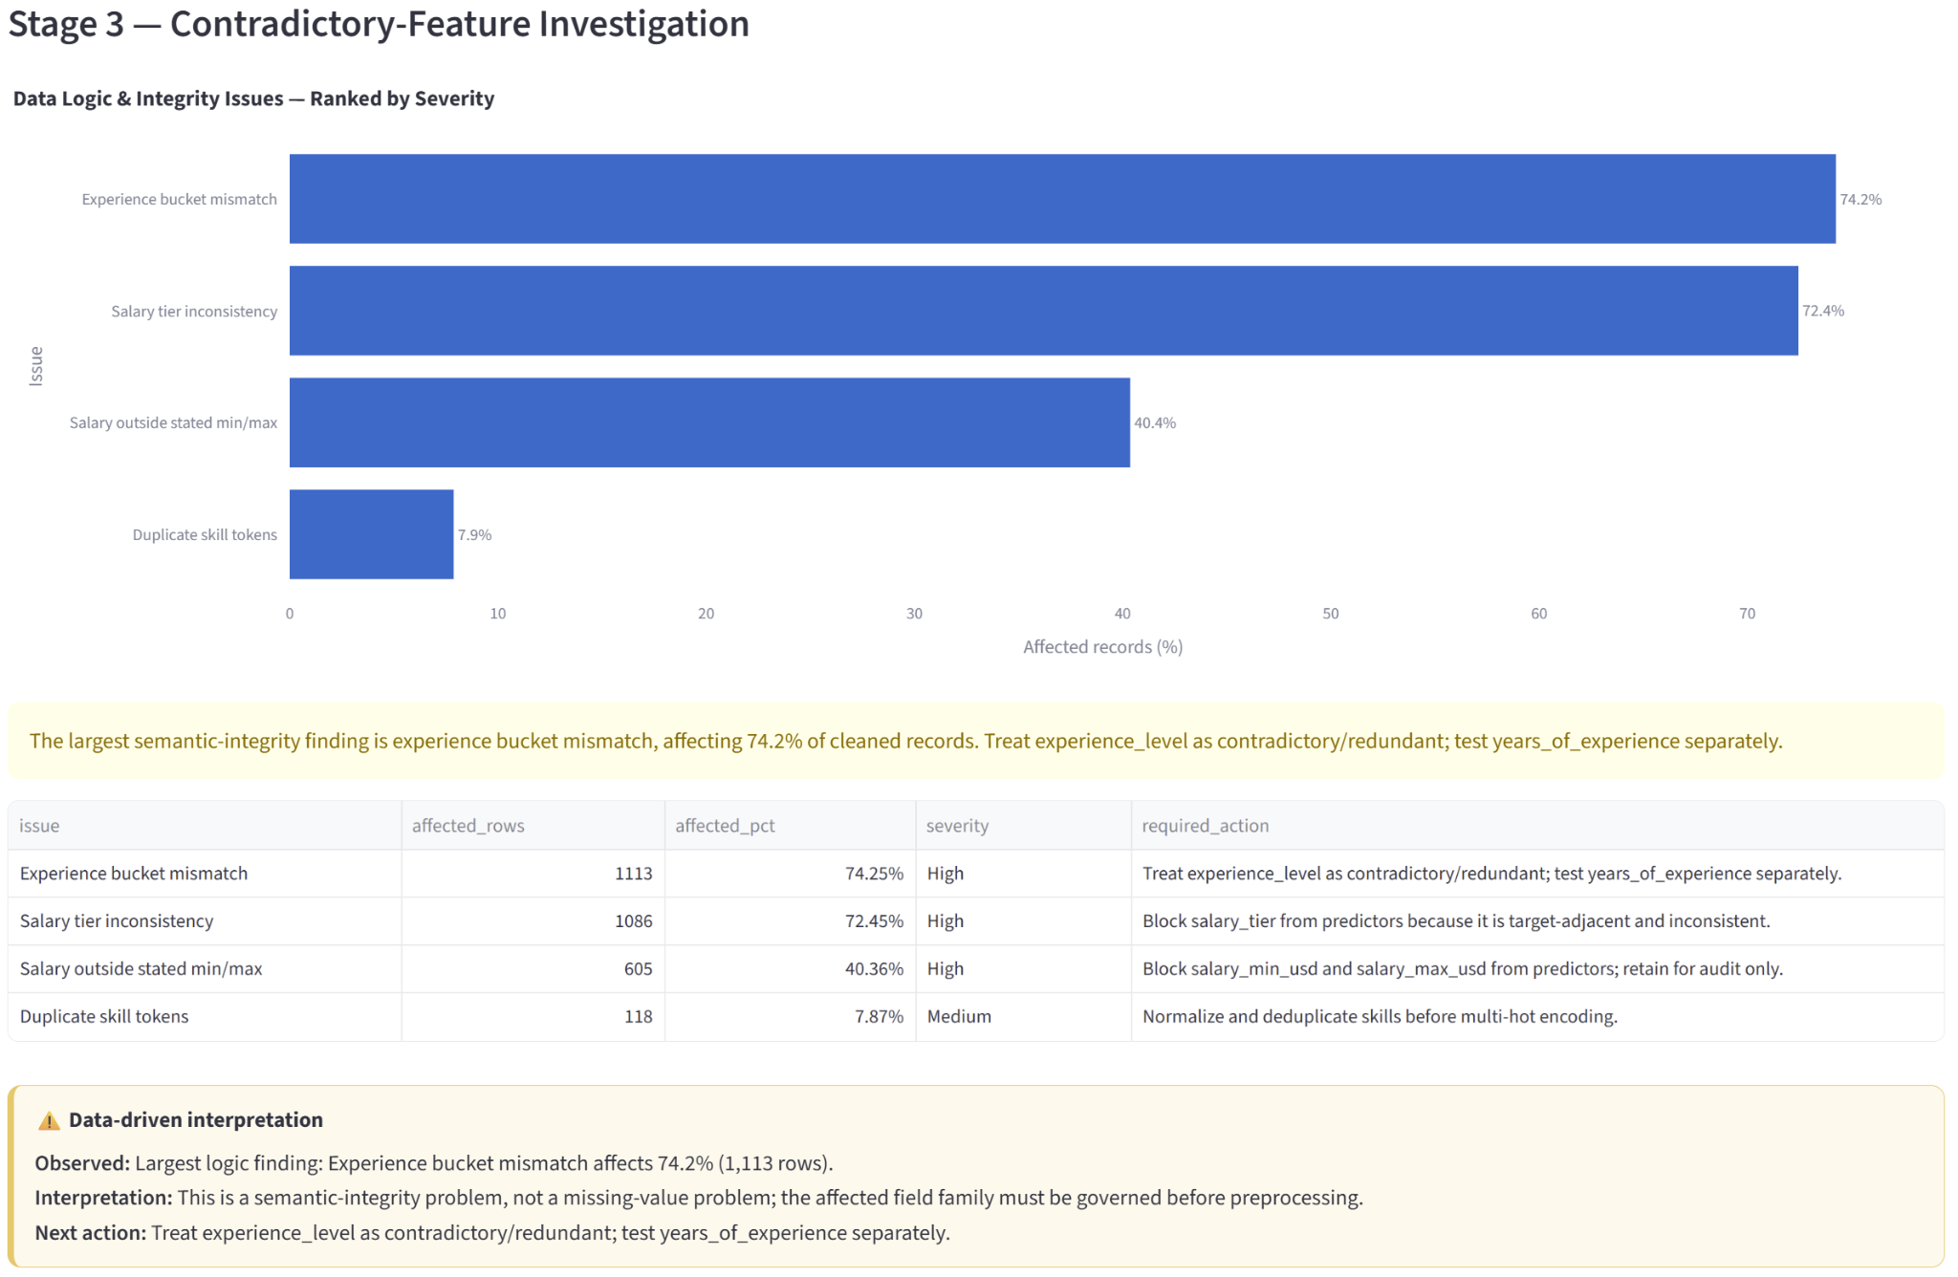
Figure 3b. share of rows affected by selected logic/integrity findings.

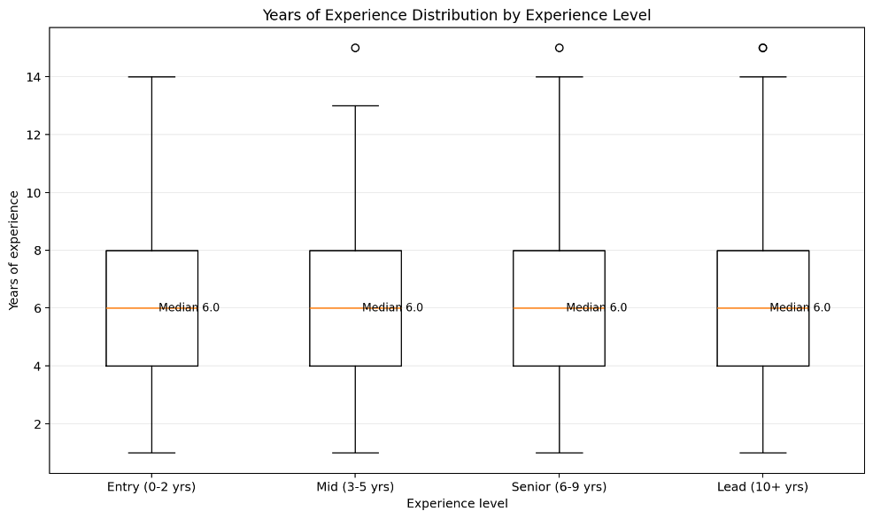
Figure 4a. year of experience distribution by experience level.
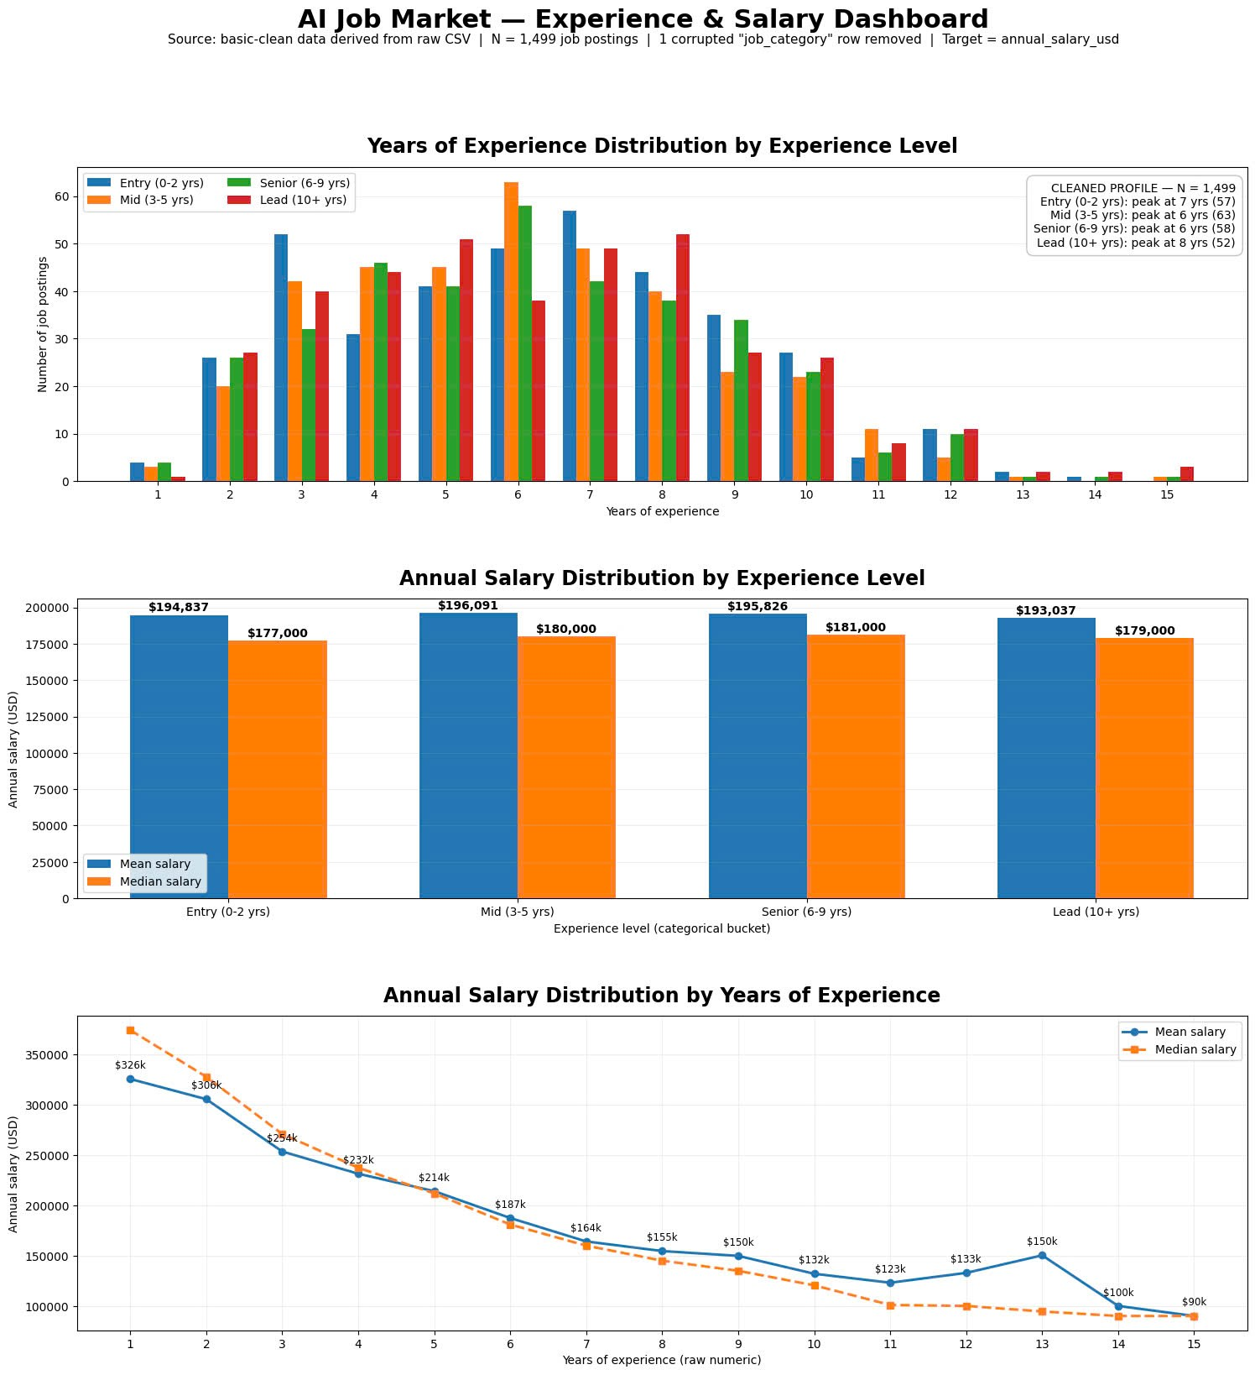
Figure 4b. annual salary distribution by experience.
- The experience dashboard shows the core contradiction very clearly: salary by experience_level is almost flat, while salary by years_of_experience declines strongly. This pattern is analytically useful, but likely reflects a synthetic artifact rather than a believable labor-market mechanism.

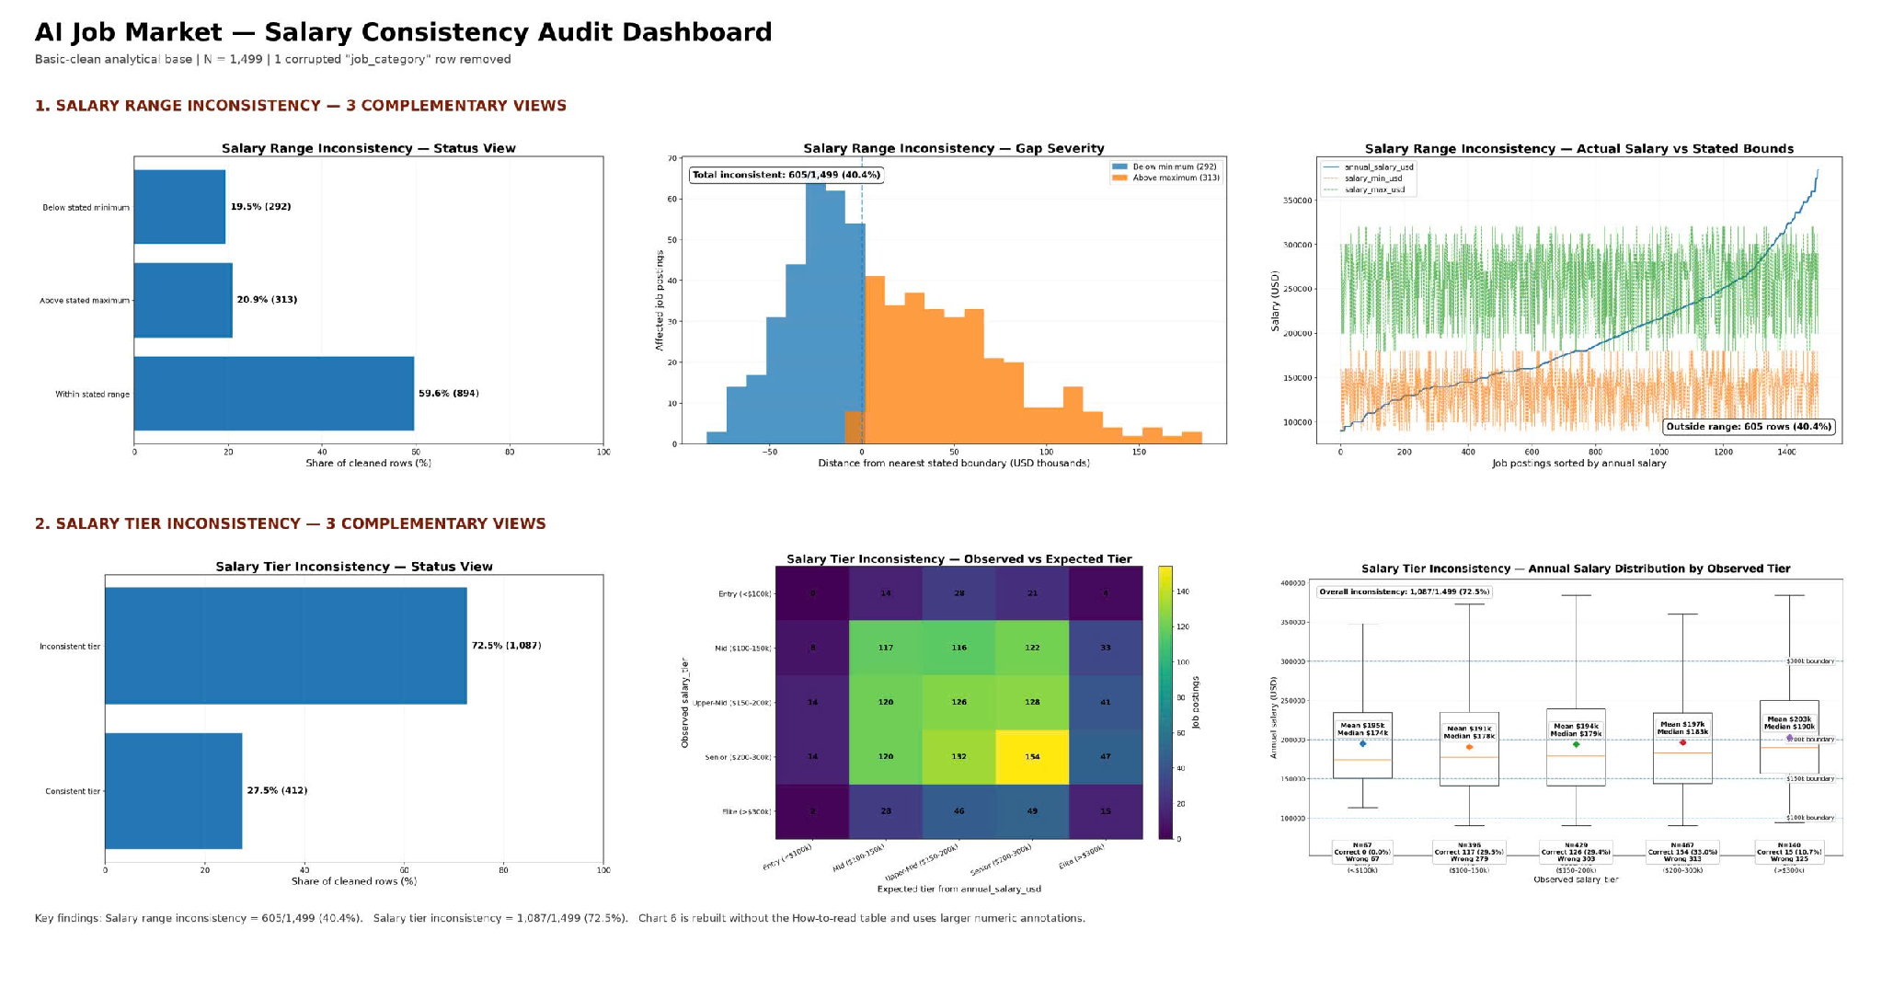
Figure 5. salary range & tier inconsistency.
- salary_min_usd and salary_max_usd should be treated as target-adjacent metadata, not stable explanatory features.
- salary_tier should be excluded from the primary model because it behaves like a noisy derivative of the target.

Clean Data | Fields
Primary keep (13) | job_title, job_category, years_of_experience, education_required, city, country, remote_work, company_size, industry, demand_score, benefits_score_10, required_skills, skill_count
Blocked / removed (12) | job_id, salary_min_usd, salary_max_usd, salary_tier, experience_level (from primary set), posting_year, posting_month, is_senior, is_remote_friendly, is_llm_role, ai_salary_premium_pct, demand_growth_yoy_pct

STAGE 4. Feature Importance & Leakage Prevention
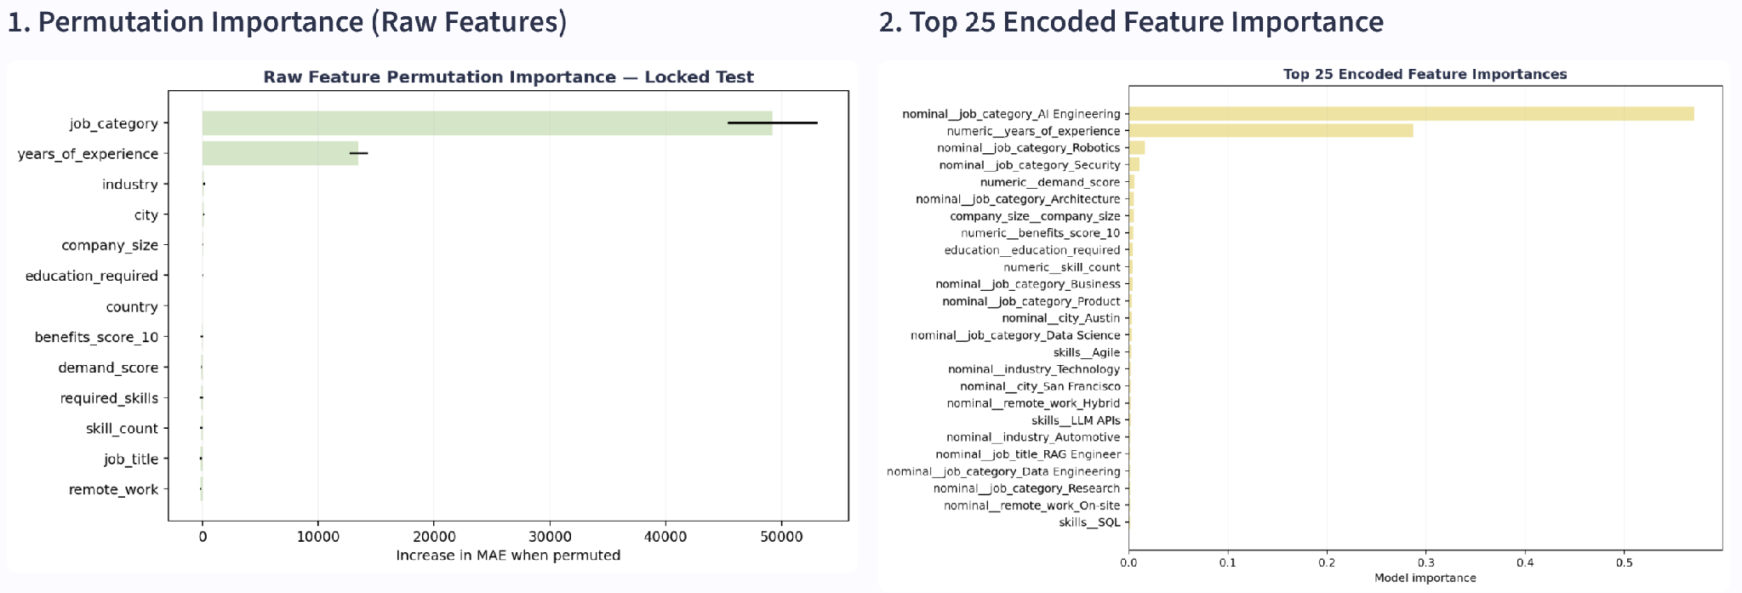
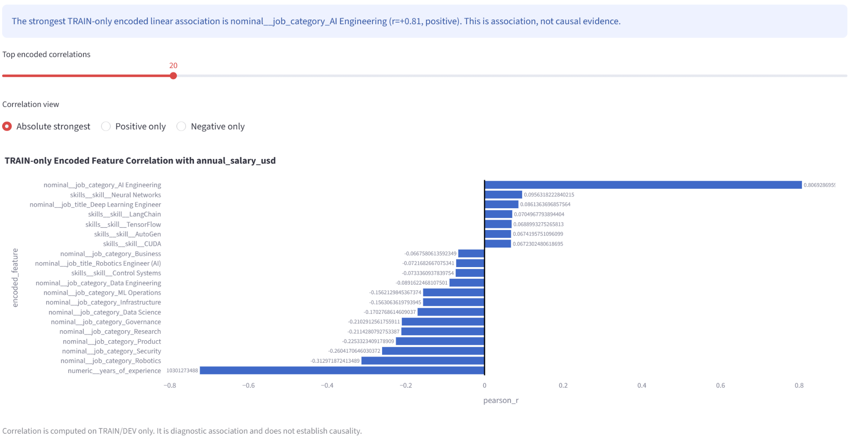
Figure 6. feature importance on Train.

- Decision next step: 4 options to run Random Forest model:
ID | Ablation Option | Feature Set (Summary)
A | Conservative Core (Baseline) | All core features (no target-adjacent fields)
B | Simplifier Option | job_category + years_of_experience
C | Job_category Exclusion | All without job_category
D | Year_of_experience Exclusion | All without years_of_experience
Key Correlation Findings
- Strongest positive: job_category (old name = AI Engineering) ≈ +0.81 — belonging to this domain is associated with substantially higher pay.
- Strongest negative: years_of_experience ≈ −0.72 — consistent with the contradictory/synthetic-looking pattern flagged in stage 5.
- Other negative signals: AI Engineering_Robotics ≈ −0.293, AI Engineering_Security ≈ −0.289, AI Engineering_Product ≈ −0.219, AI Engineering_Governance ≈ −0.214

Critical Sanity Check & Domain Reflection: A notable counter-intuitive correlation is observed where job_category shows a strong positive correlation (r ≈ +0.84) while years_of_experience exhibits a strong negative correlation (r ≈ -0.72) with salary. This pattern is a structural synthetic artifact of the dataset rather than a real-world labor market trend. While accepted for machine learning pipeline demonstration, these features are governed to prevent invalid causal claims.
Leakage Prevention Governance: Target-adjacent features including salary_min_usd, salary_max_usd, and salary_tier are explicitly blocked from model features. Removing these fields prevents target leakage and ensures the model relies solely on features available prior to salary determination.

STAGE 5. Feature Selection

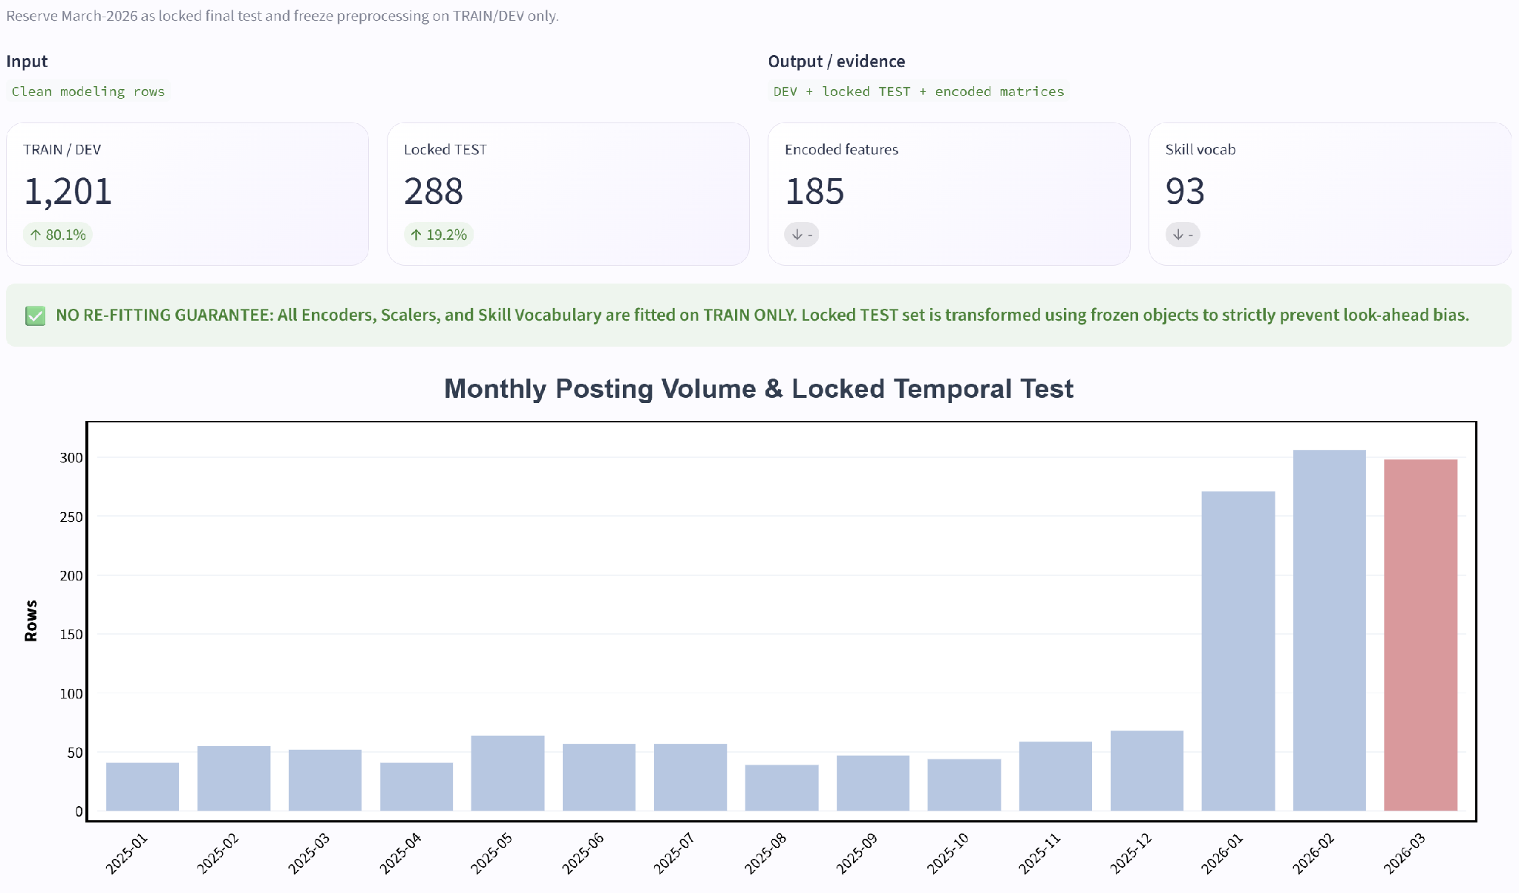
Figure 7. train – test spit.

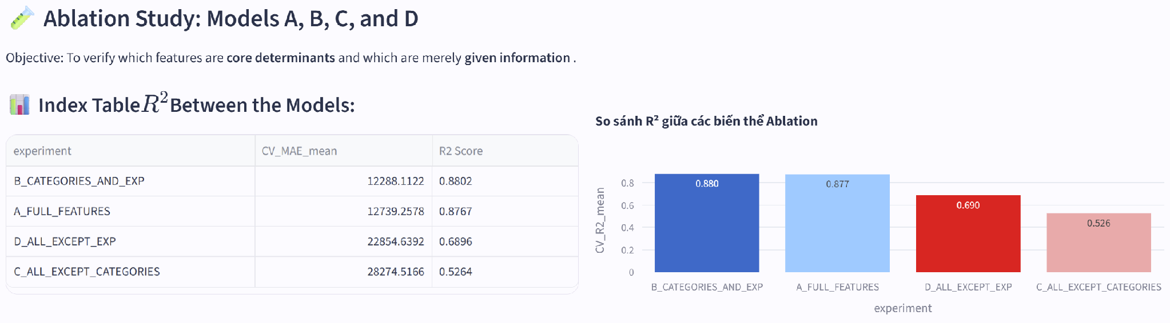
Figure 8. ablation study on 4 options with Random Forest model.

Policy group | Fields
Primary keep (2) | job_category, years_of_experience
Blocked / removed (22+1) | job_id, job_title, salary_min_usd, salary_max_usd, salary_tier, experience_level (from primary set), posting_year, posting_month, is_senior, is_remote_friendly, is_llm_role, ai_salary_premium_pct, demand_growth_yoy_pct  job_title, education_required, city, country, remote_work, company_size, industry, demand_score, benefits_score_10, required_skills, skill_count

Final Selection Decision Statement: Based on the ablation study (Figure 8), the feature set consisting of job_category and years_of_experience (Option B) is formally frozen for model training and deployment, ensuring full alignment with the locked March 2026 test evaluation policy.

Video Walkthrough & System Demonstration
Status: Video recording pending final deployment freeze.
Scope: To showcase end-to-end data ingestion, data cleaning audit, model inference execution, and Streamlit interactive dashboard walkthrough.
Link: [To be added upon completion]

BRANCH A. AI Job Market Segmentation (Unsupervised Learning)
The segmentation module is designed to explore market structure without using annual_salary_usd as a clustering target. This prevents the unsupervised view from simply reproducing salary bands and supports a separate question:
Which job postings are structurally similar in role, skill, experience, company, geography, and demand characteristics?
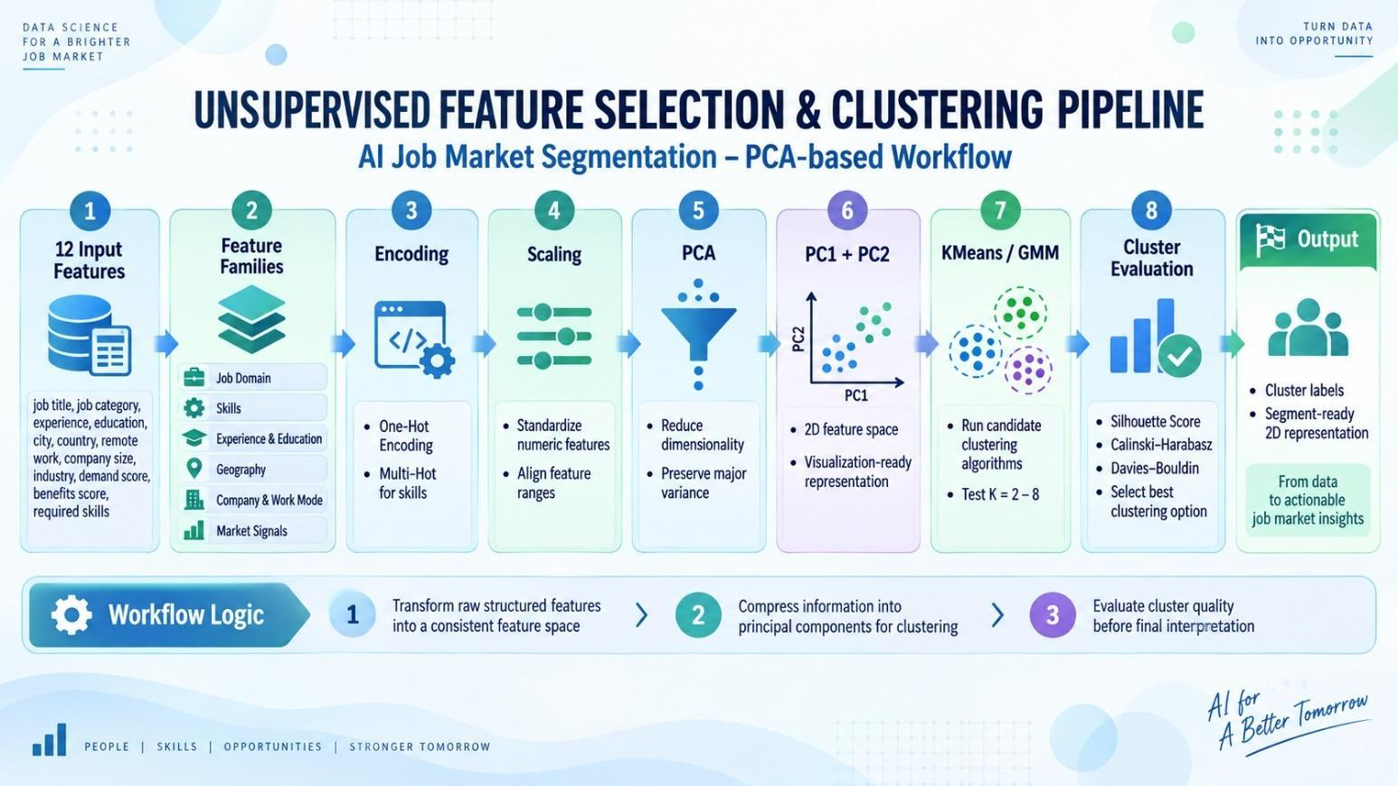
A.1 Feature families & Feature selection
Clean Data | Fields
Input Feature (12+1) | job_title, job_category, years_of_experience, education_required, city, country, remote_work, company_size, industry, demand_score, benefits_score_10, required_skills, skill_count (created based on required_skills)

Family | Representative variables | Encoded dimension in reproduced analysis
Job Domain | job_title, job_category | 37
Experience | experience_level, years_of_experience, education_required | 10
Company | remote_work, company_size, industry | 20
Geography | city, country | 34
Demand / Benefits | demand_score, demand_growth_yoy_pct, benefits_score_10, ai_salary_premium_pct | 4
Skills | 93 normalized skill tokens | 93

Option | Method | Purpose | Output Used for Clustering
O1 – PCA-based representation | PCA → PC1, PC2 | Compress many encoded features into a lower-dimensional space while preserving major variance structure | PC1, PC2
O2 – Correlation-based selection | Measure correlation between X features | Remove duplicate/redundant features and keep meaningful representative features | Selected original/encoded features
Decision | Compare O1 vs O2 using clustering metrics | Choose the feature space that produces better clusters | Best option → K search → final clustering

A.2 Family-balanced representation
Each family is independently encoded, then scaled by the square root of its encoded dimensionality before concatenation. This simple balancing rule prevents the 93-dimensional Skills family or high-cardinality one-hot blocks from receiving disproportionate weight merely because they generate more columns. The final clustering matrix reproduced from the source dataset has 198 encoded dimensions.
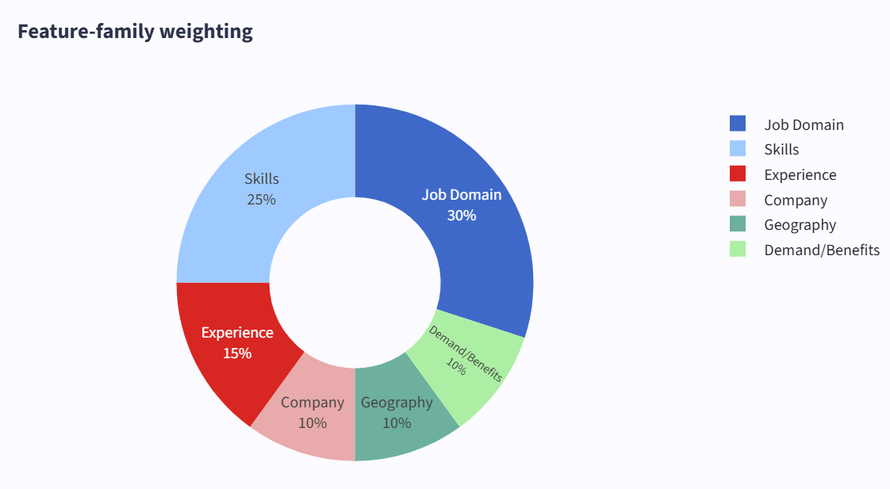
Figure 9. weight of feature families.

A.3 Cluster-number selection
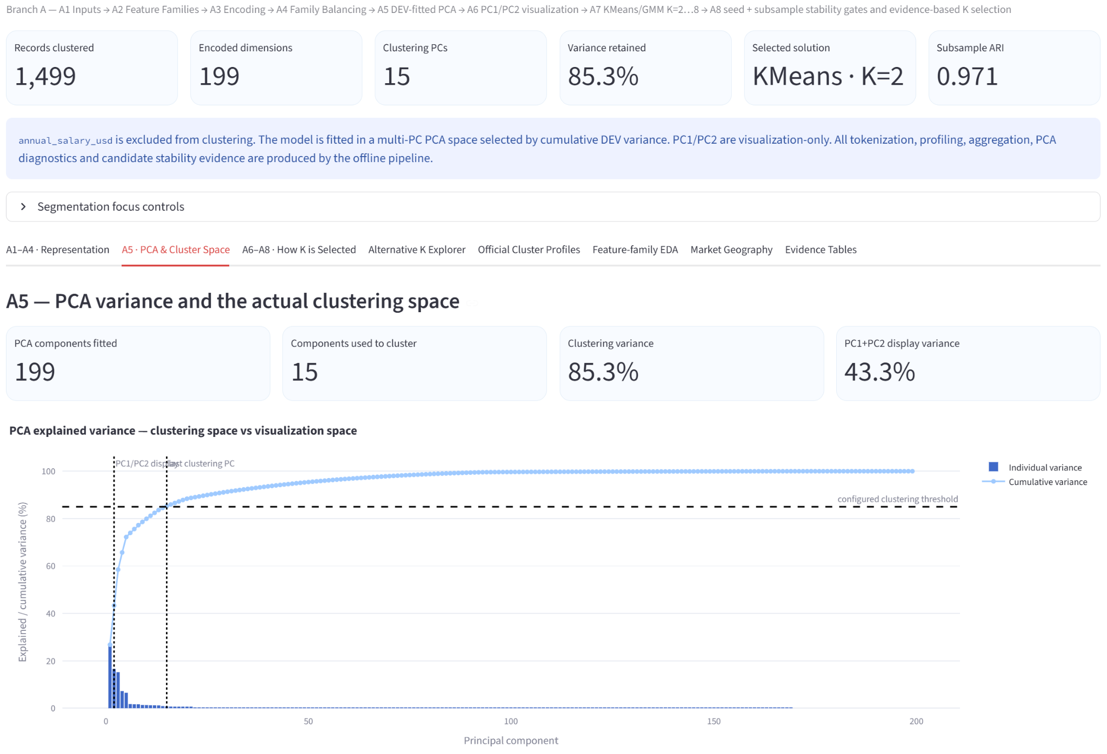
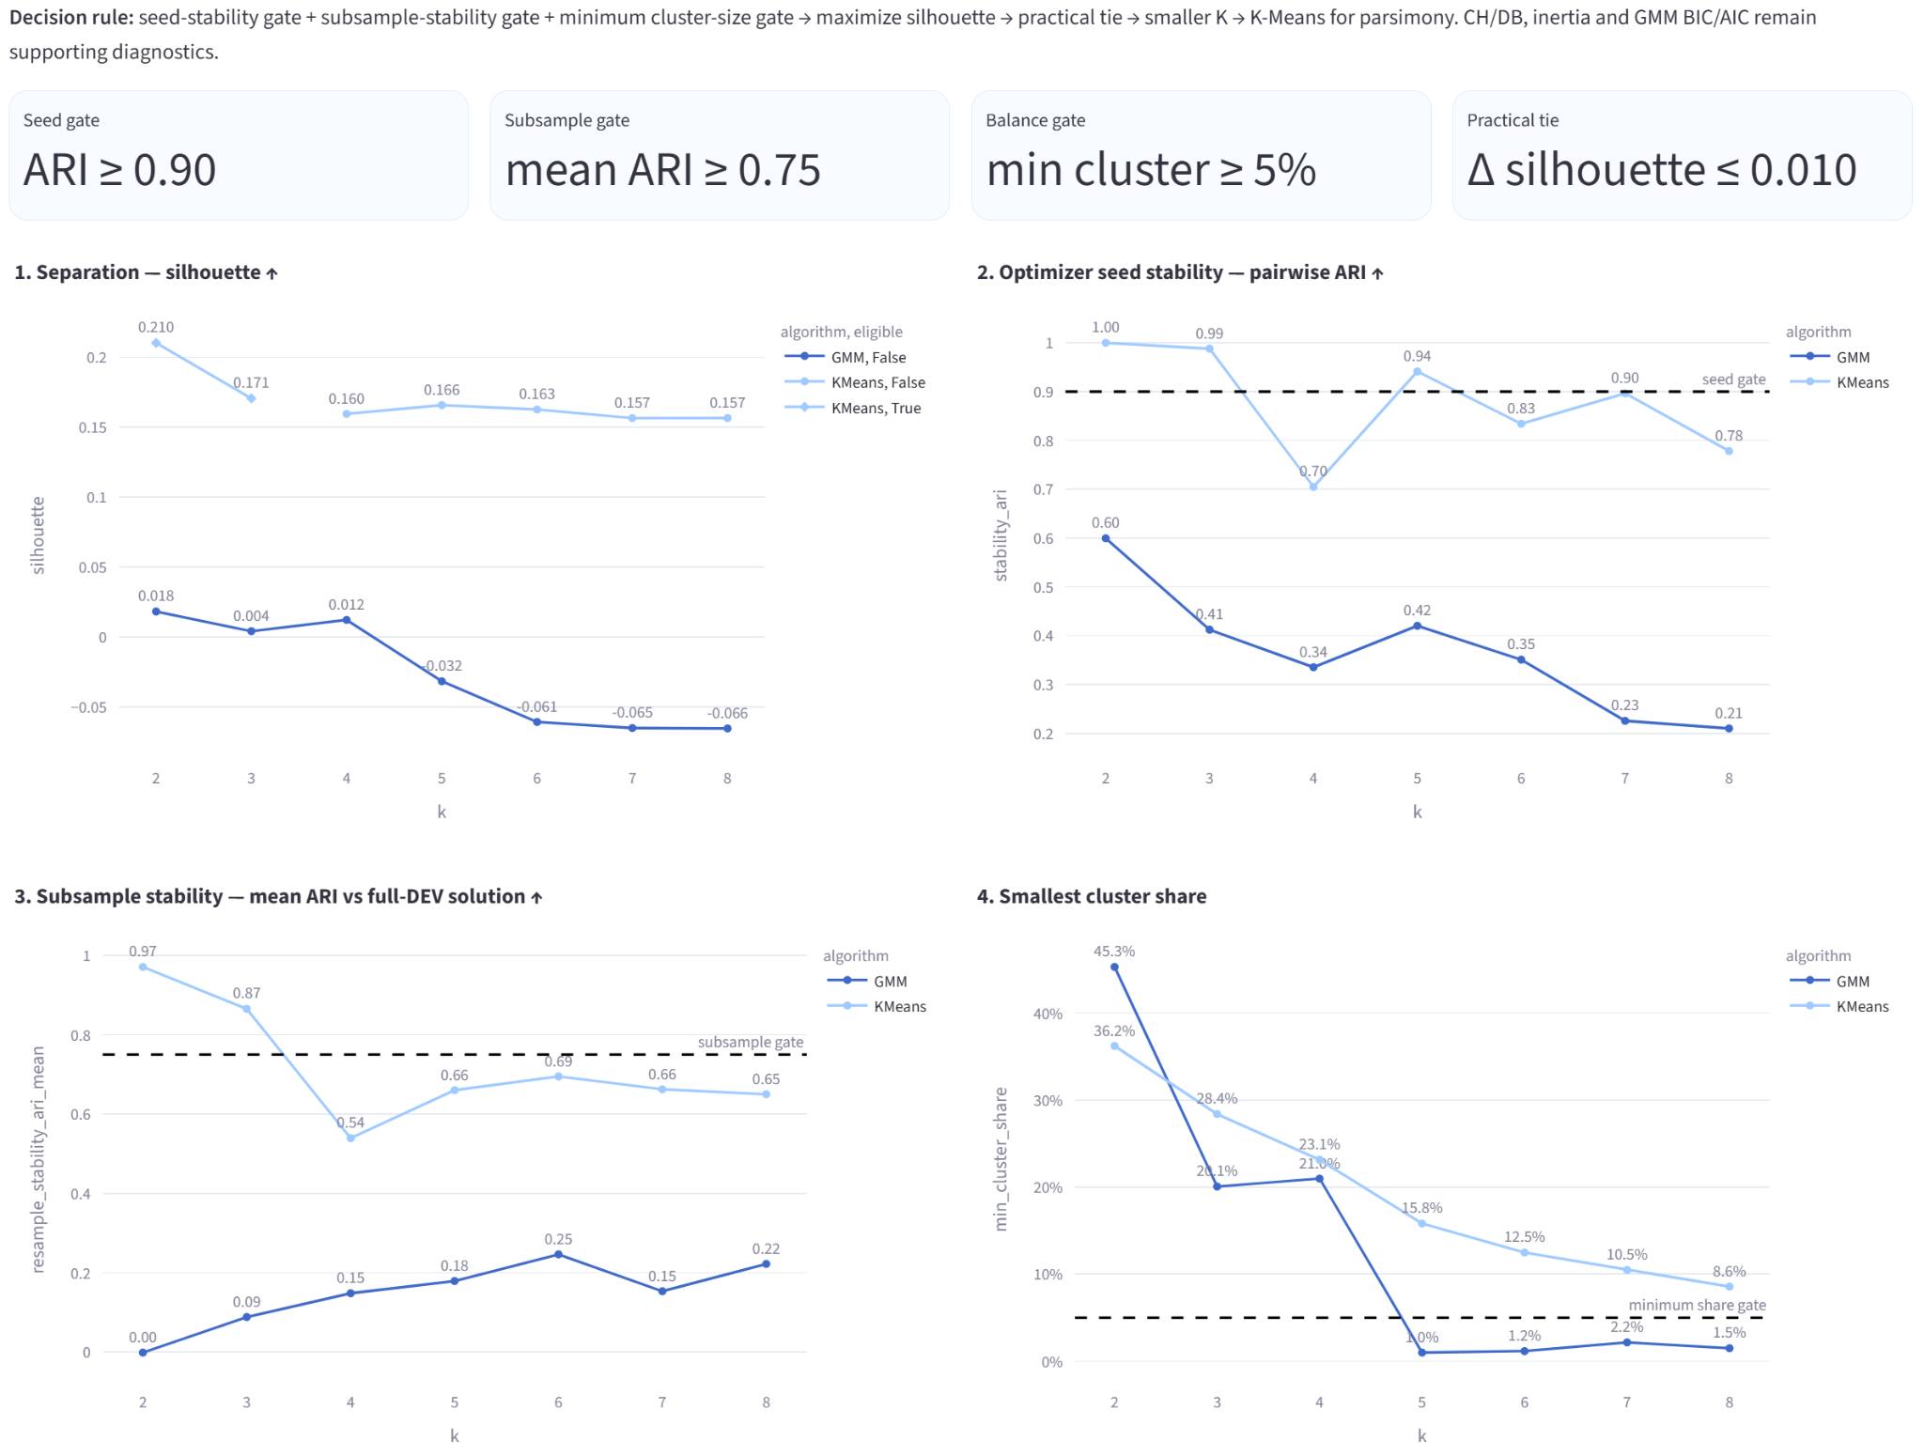
Figure 10a. analysis for K selection.
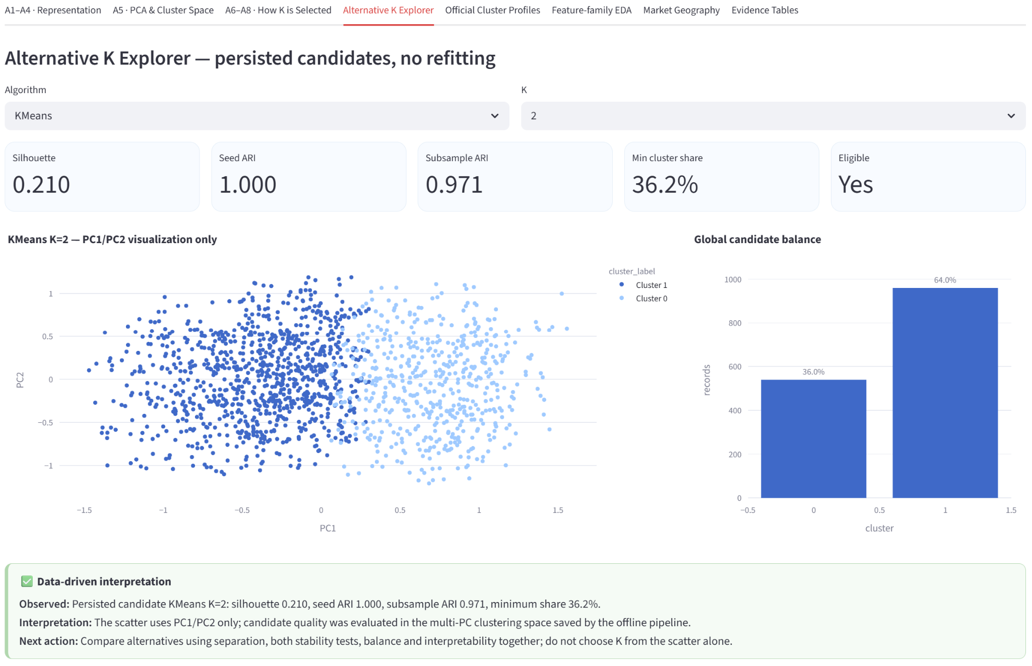
Figure 10b. Alternative K explorer.
A.4 Cluster profiles
cluster | records | salary_mean | salary_median | years_mean | demand_mean | benefits_mean | skill_count_mean | share_pct
0 | 539 | 196580 | 180000 | 5.96846 | 94.89425 | 7.909091 | 6.465677 | 35.9573
1 | 960 | 194001.5 | 180000 | 6.352083 | 83.3875 | 7.994792 | 6.1875 | 64.0427
*Salary is shown only as a post-hoc descriptive variable. It was not included as a clustering input.

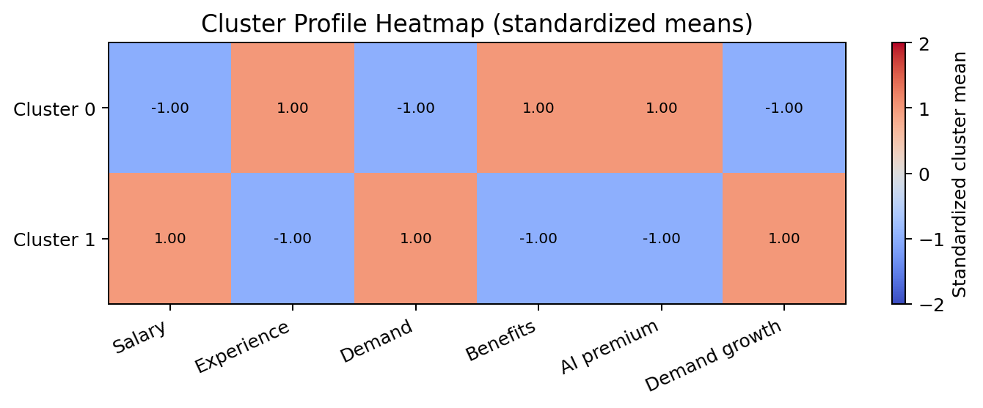
Figure 11a. Standardized cluster-level numeric profile. Values show deviations from the overall mean.
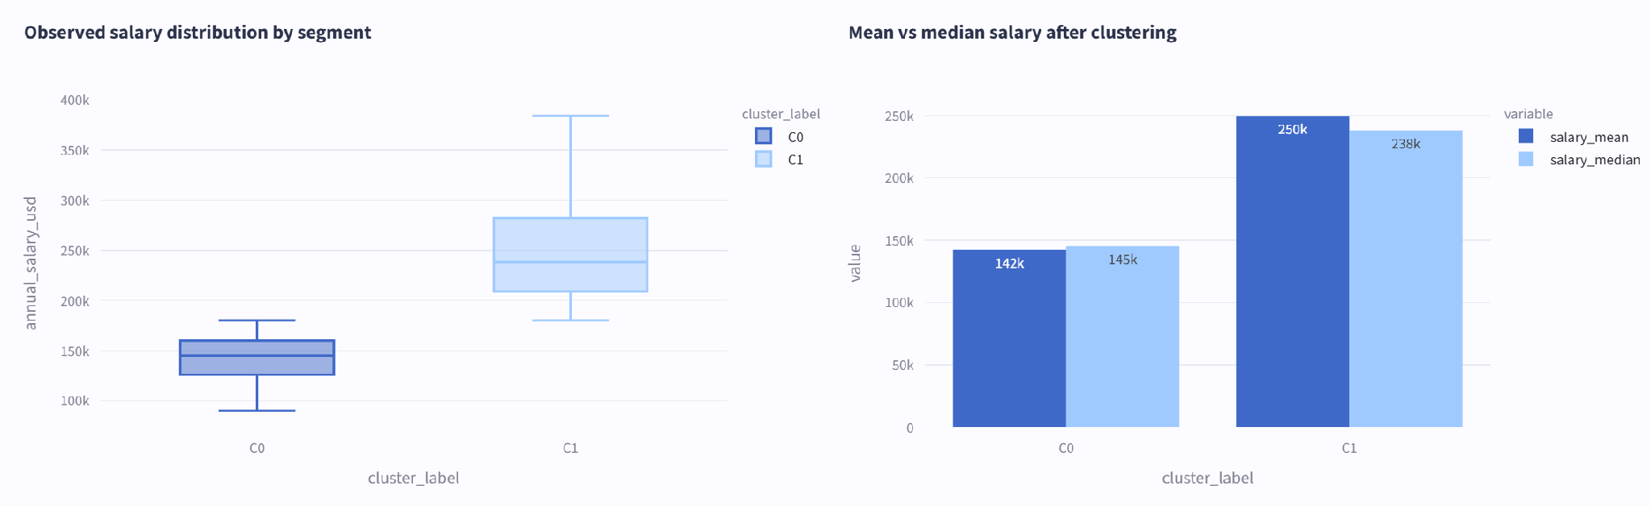
Figure 11b. salary distribution by segmentation.
8.5 Interpretation rules
Cluster labels are descriptive segments, not ground-truth classes.
A cluster does not imply causality or superiority; it represents similarity under the chosen feature representation.
Always inspect family-level distributions within clusters because a 2D projection can hide high-dimensional overlap.
Stability should be checked across random seeds and alternative algorithms such as hierarchical clustering before operational use.

BRANCH B. Salary Prediction (Supervised Learning)

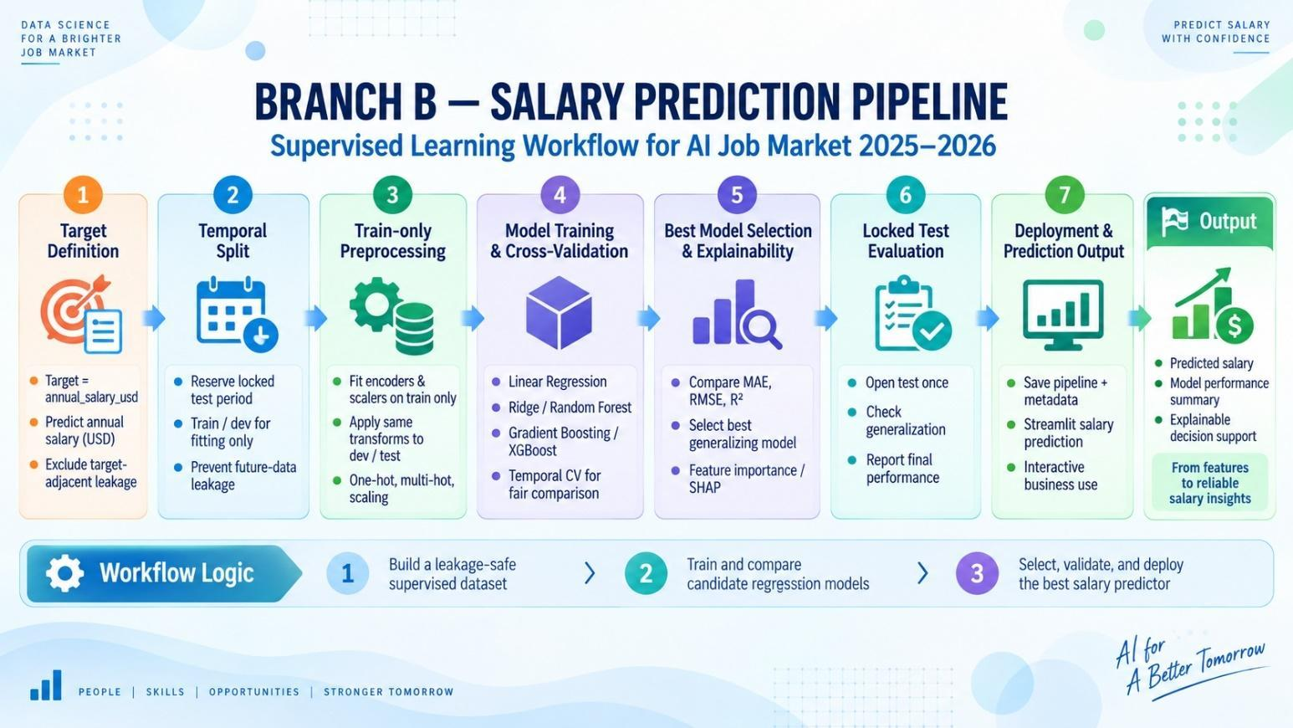

STAGE B1-2-3. Train-Test Split
- Data followed time series:
- The split was performed on the raw cleaned df (not the get_dummies df_corr), since the modelling pipeline does its own encoding internally via ColumnTransformer
- training / testing: select all records of [posting_year = 2026, posting_month = 3] for testing (about 20%), the historical data for train (around 80%).
- Train shape: approximately 1,199 rows × 11 columns
- Test shape: approximately 300 rows × 11 columns
- Locked-test rule. 2026-03 is not part of CV. Test labels are not inspected until the feature set, model class, hyperparameters, interval policy and narrative template are frozen.
- Each candidate model was wrapped in a single scikit-learn Pipeline containing a ColumnTransformer preprocessor, so the saved artifact is the entire pipeline — encoder and model together.

BEFORE VS AFTER DATA PROCESSING
Aspect | Before Processing | After Processing
Data Structure | Raw, 25 columns incl. IDs, leakage & free text | Clean, 11 modelling features, leakage-free
Corrupted Values | Header value leaked into a data row (hidden) | Identified & removed
Experience Signals | Two contradictory experience columns | Investigated; redundant column dropped
Encoding | Unsafe pd.get_dummies (analysis-only) | Deployable ColumnTransformer pipeline
Target Leakage | High risk (salary_min/max/tier present) | Fully eliminated
Model Readiness | Not Ready | Fully Ready — single deployable artifact

This comparison highlights how a data-quality-first approach — going beyond nulls and duplicates — was essential to turning this dataset into a trustworthy modelling input.

STAGE B4. Model Training & Comparison
Purpose of Stage 9: compare the approved regression candidates on identical expanding monthly validation folds, quantify accuracy and runtime trade-offs, and freeze the model family before the March 2026 locked test is opened.
9.1. Baseline and candidate model ladder:
# | Candidate | Role | Technical rationale
0 | Dummy Median | Non-ML floor | Predicts the training-fold median; every promoted model must materially outperform it.
1 | Linear Regression | Transparent linear baseline | Tests whether salary is explained by a simple additive relationship.
2 | Ridge Regression | Regularized linear baseline | Uses an L2 penalty to stabilize coefficients after one-hot expansion.
3 | Random Forest | Nonlinear bagging candidate | Captures nonlinear interactions in mixed tabular data and supports importance review.
4 | Gradient Boosting | Nonlinear boosting challenger | Sequentially corrects residuals and provides a strong stability comparison.

Every candidate is wrapped in one scikit-learn Pipeline(preprocessor → estimator). Encoding, imputation and the skill vocabulary are fitted only on the training window of each fold, which prevents validation information from leaking into preprocessing.
9.2. Temporal cross-validation design:
Fold | Training window | Validation month
1 | Jan 2025 – Sep 2025 | Oct 2025
2 | Jan 2025 – Oct 2025 | Nov 2025
3 | Jan 2025 – Nov 2025 | Dec 2025
4 | Jan 2025 – Dec 2025 | Jan 2026
5 | Jan 2025 – Jan 2026 | Feb 2026
• No shuffling is used: each validation month is later than its training window.
• All 298 records from March 2026 remain locked during candidate comparison and tuning.
• Preprocessing is fitted on the training portion and applied to the validation month using transform only.
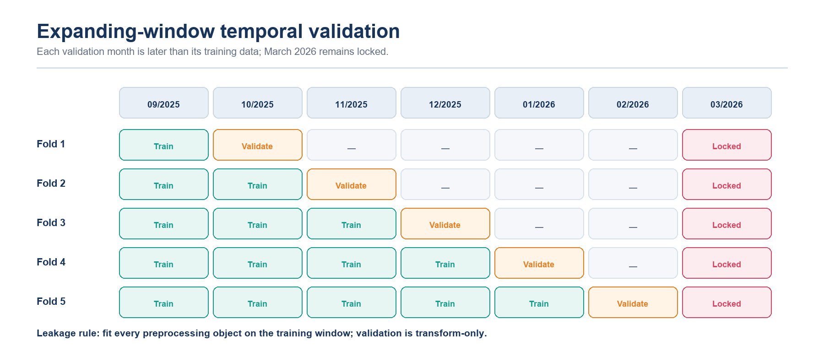
Figure 9. Expanding-window temporal validation. March 2026 remains locked until model selection and tuning are complete.
9.3. Evaluation metrics:
Metric | Priority | Interpretation
MAE | Primary | Average absolute salary error in USD; intuitive and less tail-sensitive than RMSE.
RMSE | Secondary | Penalizes large misses more strongly and exposes residual-tail risk.
R² | Diagnostic | Share of variance explained on the evaluated month; not evidence of causality.
MedAE | Robust diagnostic | Median absolute error, representing the typical prediction miss.

9.4. Temporal-CV model comparison:
Rank | Candidate | Mean MAE | MAE SD | Mean RMSE | Mean R² | Mean MedAE
1 | Random Forest | $12,594 | $2,887 | $22,923 | 0.878 | $5,216
2 | Gradient Boosting | $14,408 | $1,498 | $25,587 | 0.853 | $7,420
3 | Ridge Regression | $25,489 | $3,220 | $35,236 | 0.718 | $16,841
4 | Linear Regression | $28,827 | $3,380 | $38,680 | 0.658 | $20,606
5 | Dummy Median | $54,177 | $5,071 | $68,493 | −0.058 | $43,600

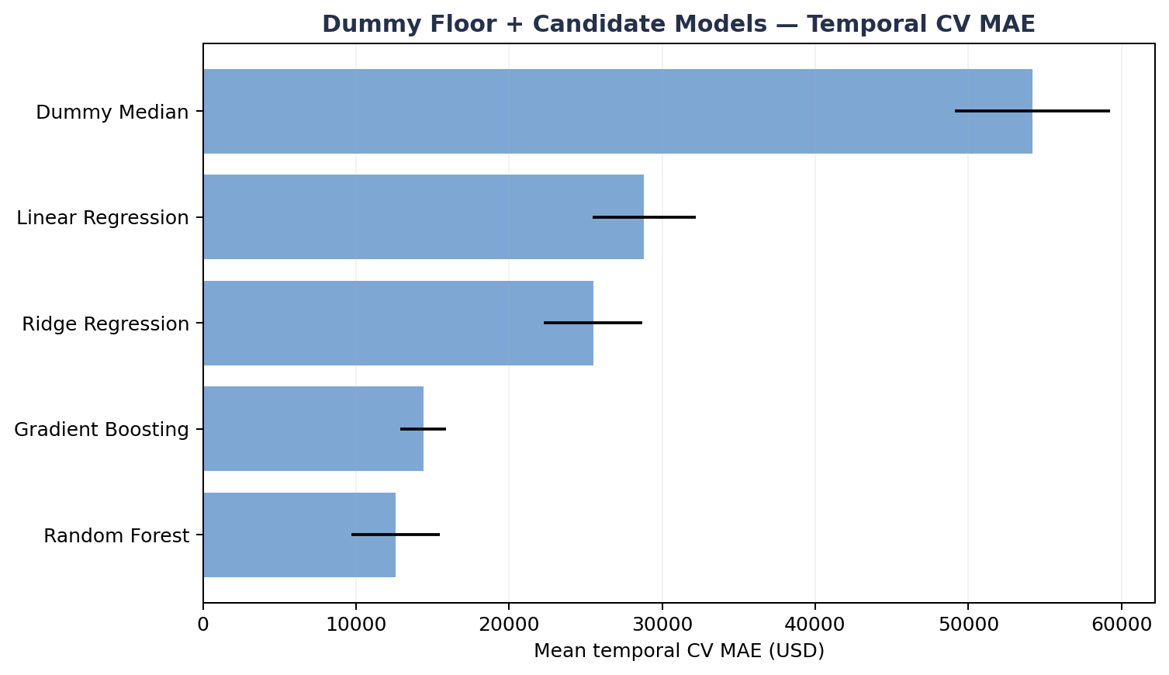
Figure 10. Mean temporal-CV MAE by candidate; lower values are better.
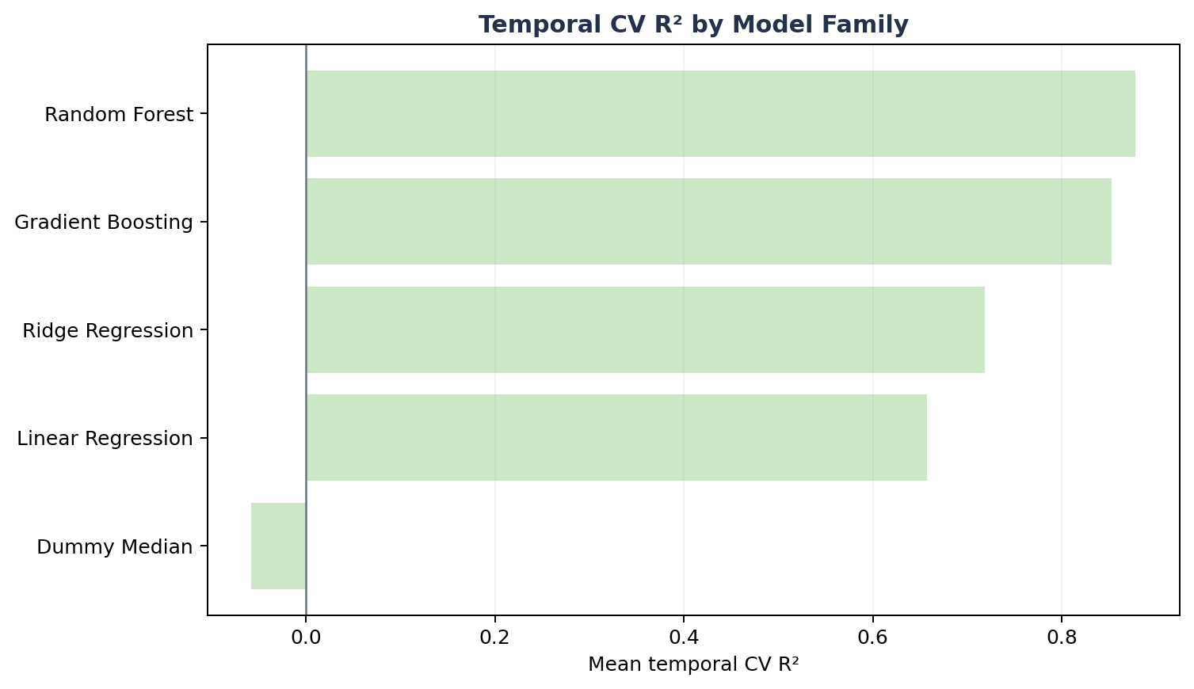
Figure 11. Mean temporal-CV R² by candidate; Random Forest provides the strongest out-of-time fit.
Result: Random Forest records the lowest mean MAE and the highest mean R². Its MAE is 12.6% lower than Gradient Boosting and 76.8% lower than the Dummy Median floor. Gradient Boosting varies less across months, but Random Forest provides the stronger aggregate accuracy evidence.
9.5. Runtime performance:
Candidate | Mean fit time / fold | Mean predict time / fold | Operational assessment
Dummy Median | 0.020 s | 0.010 s | Reference floor only
Linear Regression | 0.051 s | 0.010 s | Very fast
Ridge Regression | 0.023 s | 0.009 s | Very fast
Random Forest | 0.486 s | 0.016 s | Suitable for offline fitting and interactive inference
Gradient Boosting | 0.410 s | 0.010 s | Suitable for offline fitting and interactive inference

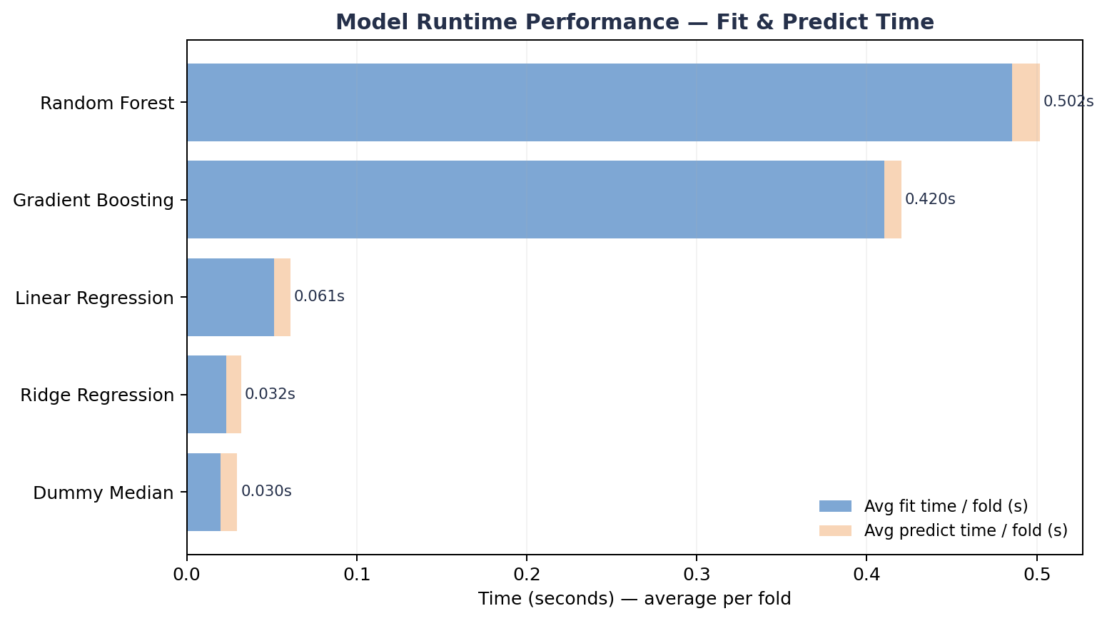
Figure 12. Mean fit and prediction time per temporal fold.
Assessment: both nonlinear candidates are operationally lightweight at this data scale. Model choice is therefore driven by temporal accuracy and diagnostic evidence rather than runtime.
9.6. Feature-family ablation:
Experiment | Feature set | Mean MAE | Improvement vs A0
A0 | Conservative core | $23,019 | —
A1 | A0 + years_of_experience | $12,357 | 46.3%
A2 | A0 + experience_level | $22,888 | 0.6%
A6 | A1 + required_skills + skill_count | $12,739 | 44.7%

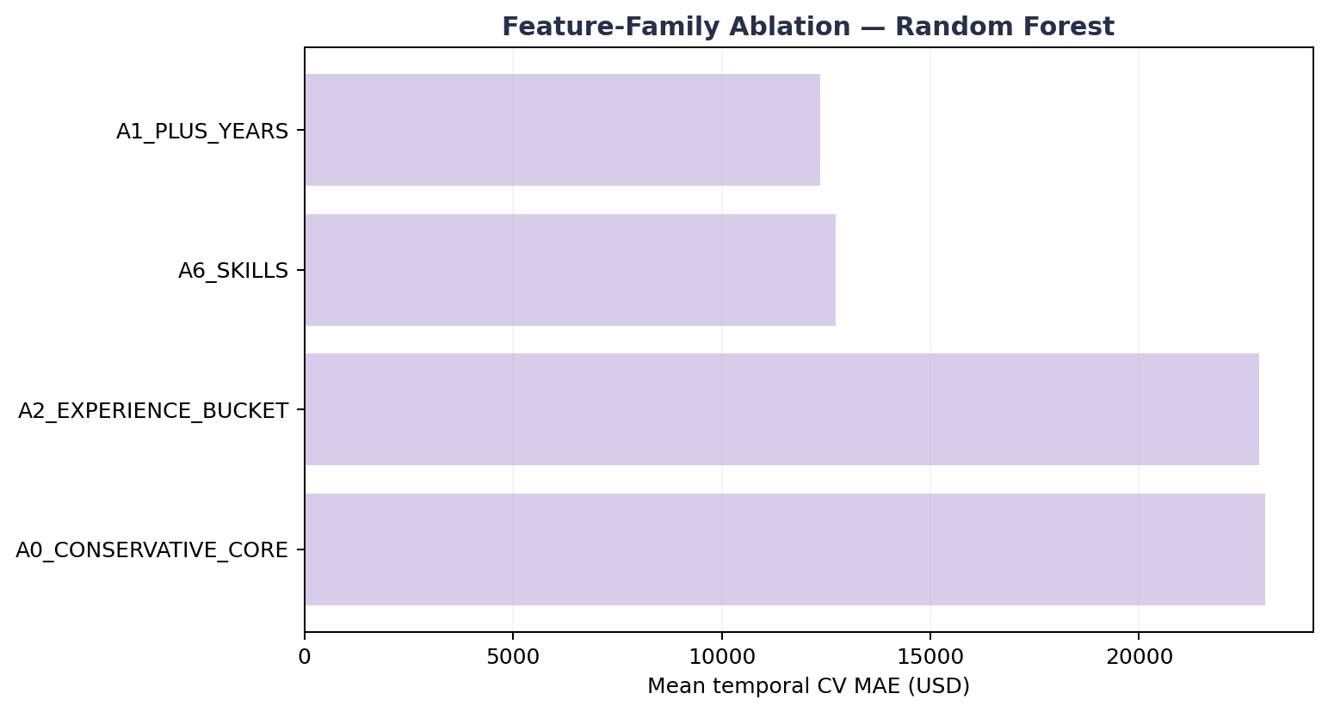
Figure 13. Feature-family ablation measured by mean temporal-CV MAE.
Assessment: years_of_experience provides the dominant predictive gain. The skill-aware A6 contract is 3.1% worse than A1 in this run, so skills should not be described as an accuracy improvement. They remain in the deployable contract for scenario detail and future retraining, with this limitation stated explicitly.
Stage outcome: Random Forest advances to bounded tuning in Stage 10. The family decision is frozen before the locked test is opened.

STAGE B5-6. Best Model Selection
Purpose of Stage 10: tune the selected model family inside the development period, evaluate the frozen configuration once on the locked test, and distinguish predictive reliance from causal interpretation.
10.1. Bounded hyperparameter tuning:
Rank | Trees | Minimum leaf | Feature fraction | Maximum depth | CV MAE | MAE SD
1 | 300 | 2 | 0.7 | 20 | $12,425 | $3,115
2 | 100 | 2 | 0.8 | None | $12,497 | $3,018
3 | 80 | 1 | 0.8 | None | $12,581 | $2,998
4 | 200 | 1 | 0.7 | 20 | $12,615 | $3,012

Selected configuration: n_estimators=300, min_samples_leaf=2, max_features=0.7 and max_depth=20. This candidate achieves the lowest tuning CV MAE while constraining leaf size and tree depth on a modest development sample.
10.2. Final locked-test evaluation:
Selected model | Locked MAE | Locked RMSE | Locked R² | Locked MedAE | CV-to-test MAE gap
Random Forest | $15,005 | $29,819 | 0.803 | $4,354 | +20.8% vs tuning CV

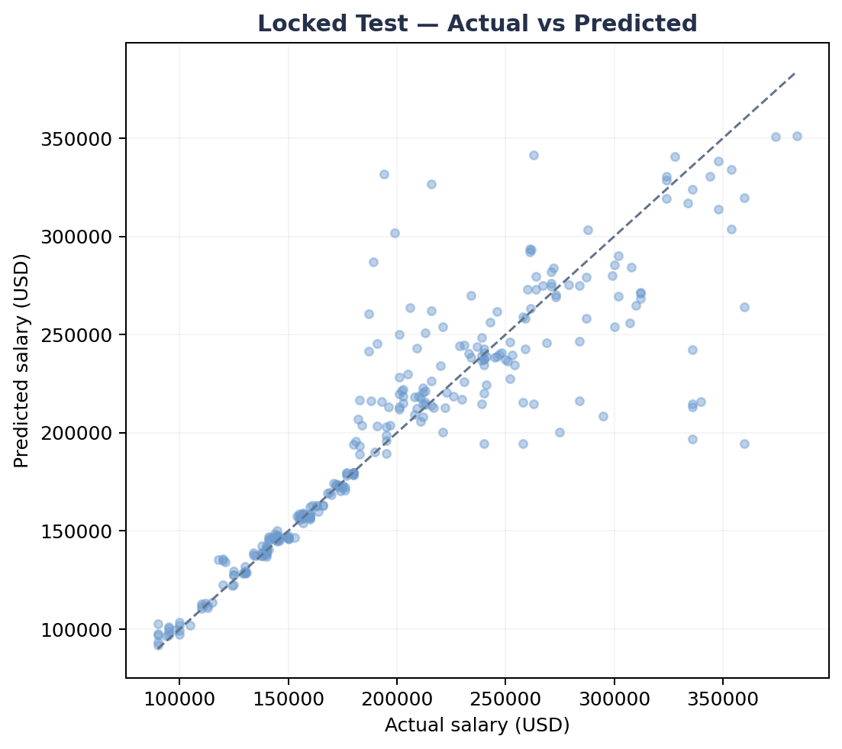
Figure 14. Actual versus predicted annual salary for the 298 locked-test records.
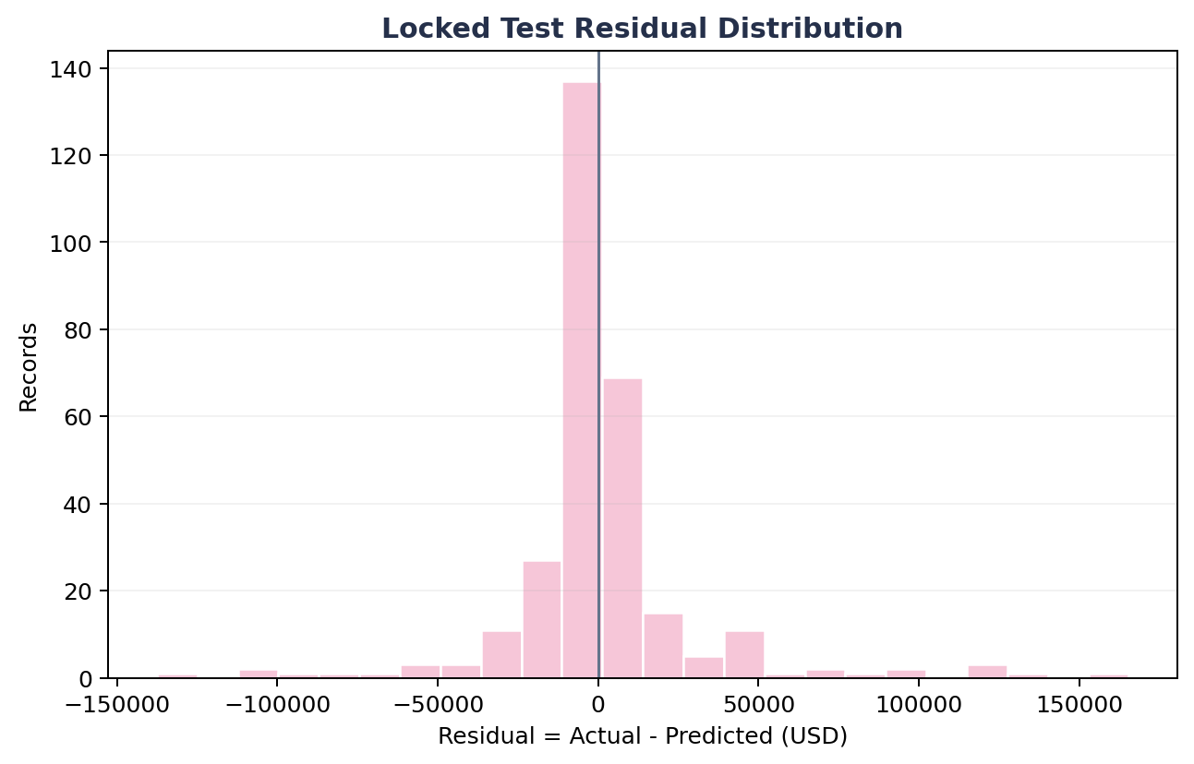
Figure 15. Locked-test residual distribution; the longer tail explains why RMSE is much larger than MedAE.
Evaluation: locked-test MAE is higher than the tuning-period CV MAE, which is expected for a strictly future month. The much lower MedAE relative to RMSE shows that most predictions are close, while a smaller number of large misses dominate tail-sensitive error.
10.3. Practical prediction interval:
Uncertainty item | Observed value | Interpretation
90th-percentile absolute error | $32,028 | Empirical width derived from held-out error
Displayed lower bound | max(0, prediction − $32,028) | Prevents a negative salary bound
Displayed upper bound | prediction + $32,028 | Symmetric practical error band

The interface must label this as an empirical validation-error band. It is not a formal confidence interval and does not guarantee 90% coverage on a new market.
10.4. Feature reliance review:
Method | Leading feature | Observed importance | Meaning
Encoded impurity | job_category_AI Engineering | 57.04% | Frequently used by the fitted trees to reduce training impurity
Encoded impurity | years_of_experience | 28.69% | Strong nonlinear split variable
Raw permutation | job_category | +$51,387 MAE | Largest loss when the raw field is destroyed
Raw permutation | years_of_experience | +$12,668 MAE | Second strongest model reliance

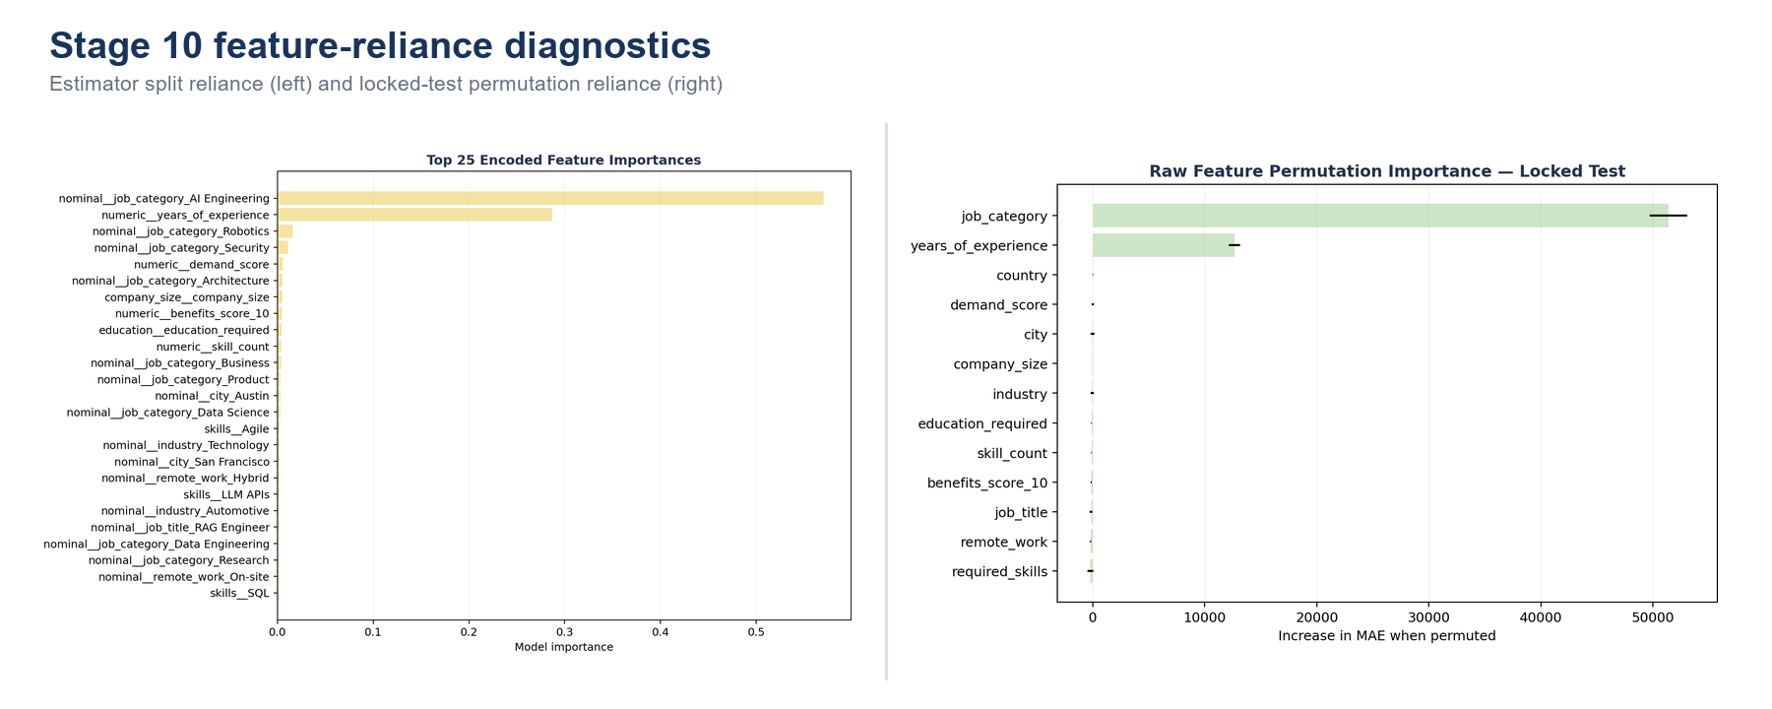
Figure 16. Encoded impurity importance and raw-feature permutation importance describe complementary forms of model reliance.
Interpretation: high feature importance does not mean low error for that category. AI Engineering is both the dominant split signal and the most heterogeneous locked-test segment (156 records; MAE approximately $26,319), so the model relies on it heavily while still making larger within-category errors. Importance measures model dependence, not class balance, accuracy or causality.
• The fitted model behaves largely as a two-signal system: job category plus years of experience.
• The experience relationship is synthetic-looking and contradictory in this dataset; reliance on it is not a real-world salary law.
• R²=0.803 describes fit to this locked month only and must not be extrapolated to the entire AI labor market.
Stage outcome: retain Random Forest for academic benchmarking and scenario exploration. External validation is required before operational compensation decisions.

STAGE B7. Save Deployable Pipeline + Metadata
Purpose of Stage 11: package the fitted preprocessing and final estimator as one deployable pipeline, then store the metadata required to validate raw inputs and reproduce the offline inference contract.
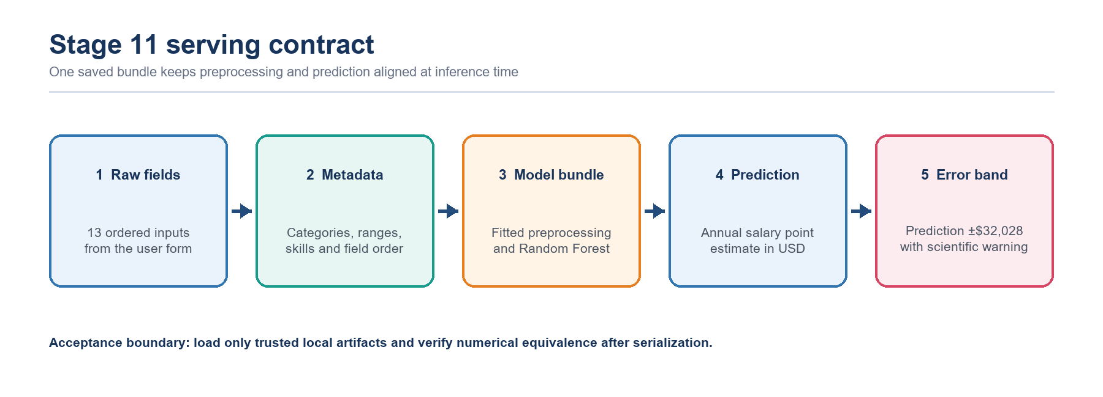
Figure 17. Serving flow from raw form fields through metadata validation and the saved model bundle to the point estimate and practical error band.
11.1. Serialized artifact contract:
Artifact | Purpose | Acceptance evidence
artifacts/model_bundle.joblib | Complete preprocessor + fitted Random Forest pipeline used by Streamlit | Loads without error
artifacts/preprocessor_ml_ready.joblib | Reusable fitted data transformer | File present and loadable
artifacts/metadata.json | Model identity, input contract, ranges, categories, skills, metrics and limits | Required keys validated
artifacts/feature_columns.json | Exact ordered raw feature contract | 13 fields in serving order
artifacts/11_bundle_equivalence.json | Reloaded-bundle numerical equivalence check | max_abs_diff = 0

11.2. Metadata data contract:
Metadata field | Current value | Streamlit use
model_name | Random Forest | Labels the inference result
model_features | 13 ordered raw inputs | Builds the serving DataFrame in the trained order
numeric_ranges | experience 1–15; demand 68–98; benefits 6–10 | Constrains numeric controls
category_options | Training-domain values | Populates select boxes
skill_vocabulary | 93 tokens | Populates the multiselect and derives skill_count
prediction_interval_abs_error_q90 | $32,028 | Calculates the displayed practical bounds
limitations | Four documented limitations | Shows the scientific-use boundary

{
"model_name": "Random Forest",
"model_features": ["job_title", "job_category", "years_of_experience", "..."],
"locked_test": {"year": 2026, "month": 3, "rows": 298},
"prediction_interval_abs_error_q90": 32027.76,
"selected_hyperparameters": {"n_estimators": 300, "min_samples_leaf": 2,
"max_features": 0.7, "max_depth": 20}
}

11.3. Packaging and verification procedure:
1. Fit the complete preprocessing and selected estimator on all 1,201 development records after model selection is frozen.
2. Serialize the entire pipeline as model_bundle.joblib so raw application fields follow the same transformation sequence used offline.
3. Write the ordered feature contract, categories, numeric ranges, skill vocabulary, final metrics, interval width and limitations to metadata.
4. Reload the bundle and compare predictions with the pre-save output under a strict numerical tolerance.
Check | Method | Acceptance criterion | Current status
Bundle load | joblib.load from the trusted local path | No exception | Passed
Feature order | Compare DataFrame columns with metadata | Exact 13-field order | Passed
Unknown categories | Run a controlled unseen-category record | No encoder failure | Supported by handle_unknown
Reload equivalence | Compare pre-save and reloaded predictions | max_abs_diff ≤ 1e−9 | Passed: 0
Provenance | Record package versions and timestamp | Reproducible environment | Keep with release evidence

Assessment: saving one end-to-end bundle minimizes training-serving skew. Metadata closes the loop between training and the UI, but production deployment still requires secret management, version provenance and external-data monitoring.

STREAMLIT. Salary Prediction Dashboard
Purpose of Stage 12: provide an authenticated, metadata-driven Streamlit page that validates proposed job records, stores valid records in a session queue, predicts the full queue with the saved model bundle and communicates uncertainty for every result.
Latest interface clarification: the queue mechanism remains part of the Salary Prediction page. The only presentation change is the removal of the dedicated Stage 11 Deployment Gate panel from the Best Model page. This does not remove validation, metadata checks or the saved artifacts used during prediction; it removes a duplicated Stage 11 display from the Stage 10 evaluation page.
12.1. Authentication and role-based controls:
Role | Demo credential | Visible controls | Security note
Admin | admin / AIJob2026! | All evidence pages; manual demand and benefits fields | Local academic demonstration only
User | user / user123 | Simplified prediction view; market scores use training medians | Replace password handling before shared deployment

The selected role is stored in the Streamlit session. Admin users can edit the two market-score inputs; standard users do not see these fields and the application supplies the training-domain median values so the 13-field model contract remains complete. Environment variables may override the administrator account in a controlled deployment.
12.2. Separation of page responsibilities after the interface update:
Area | What is displayed | What remains active
Best Model page | Stage 10 tuning, locked-test metrics, diagnostics, importance and evaluation examples | No dedicated Stage 11 Deployment Gate panel is shown
Stage 11 artifact layer | Not presented as a separate tab inside Best Model | model_bundle.joblib, metadata.json and the ordered feature contract are still required by inference
Salary Prediction page | Stage 12 form, Validation Queue, batch results and CSV controls | Input validation, queue state and saved-bundle prediction remain unchanged

Design rationale: evaluation evidence and inference controls serve different purposes. Keeping Stage 10 evidence on Best Model avoids a duplicated deployment panel, while keeping the operational gate and queue on Salary Prediction preserves the complete user workflow.
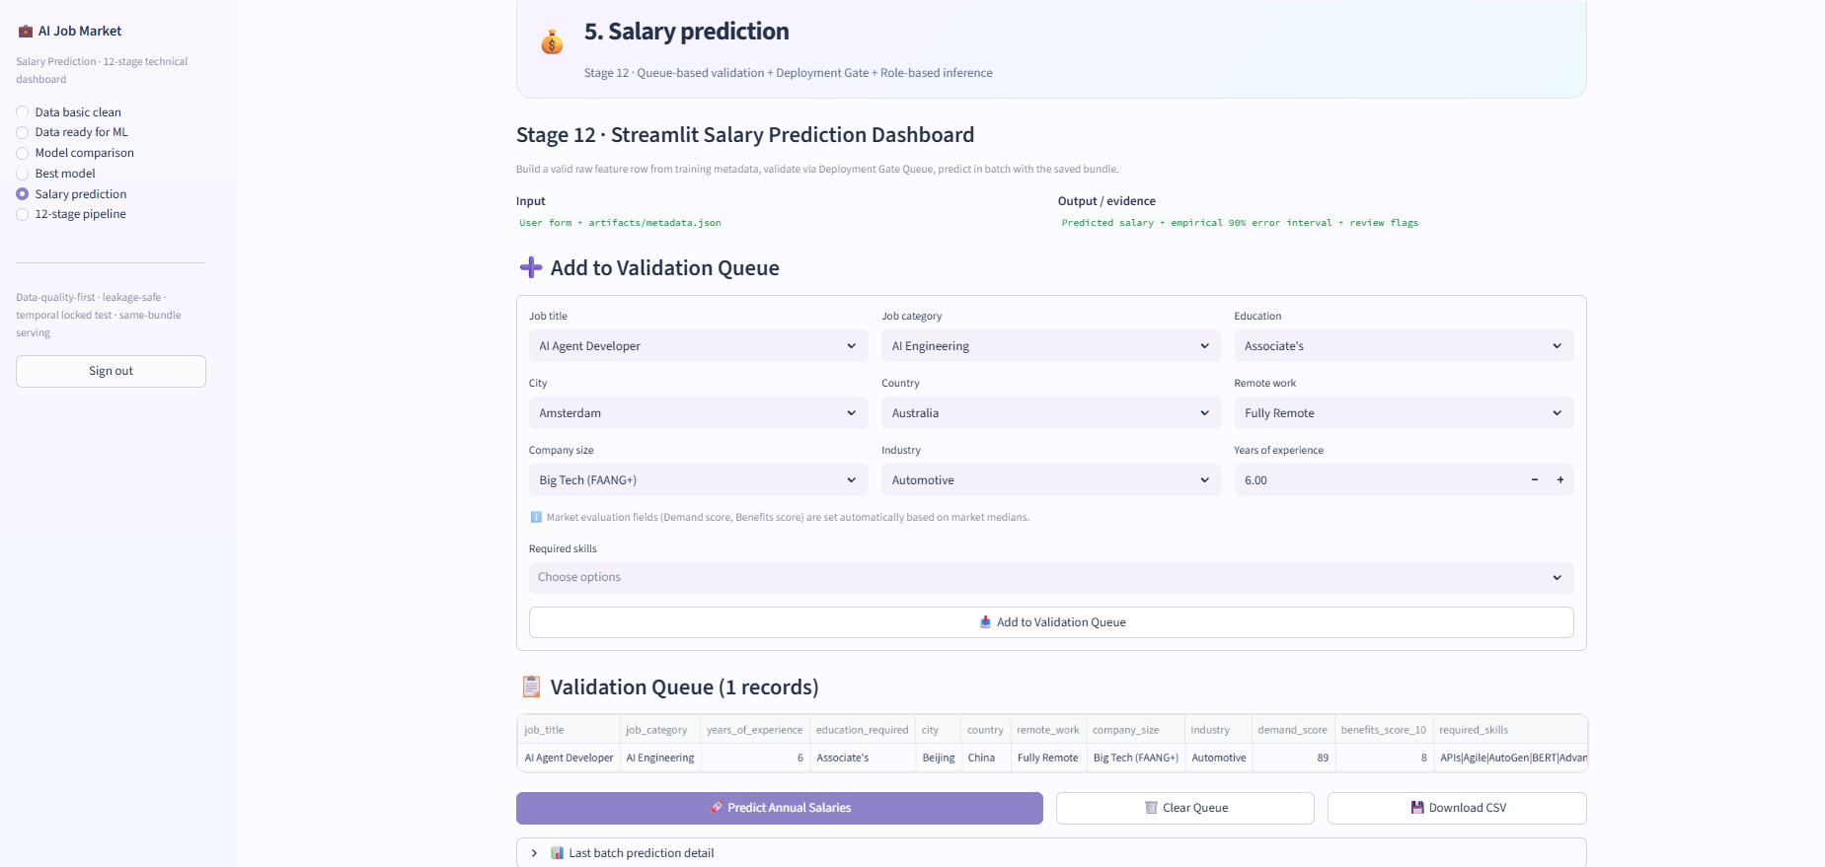
Figure 18. Current Salary Prediction page with Add to Validation Queue, queued records, batch prediction, queue clearing and CSV download controls.
12.3. Queue-based validation and batch prediction:
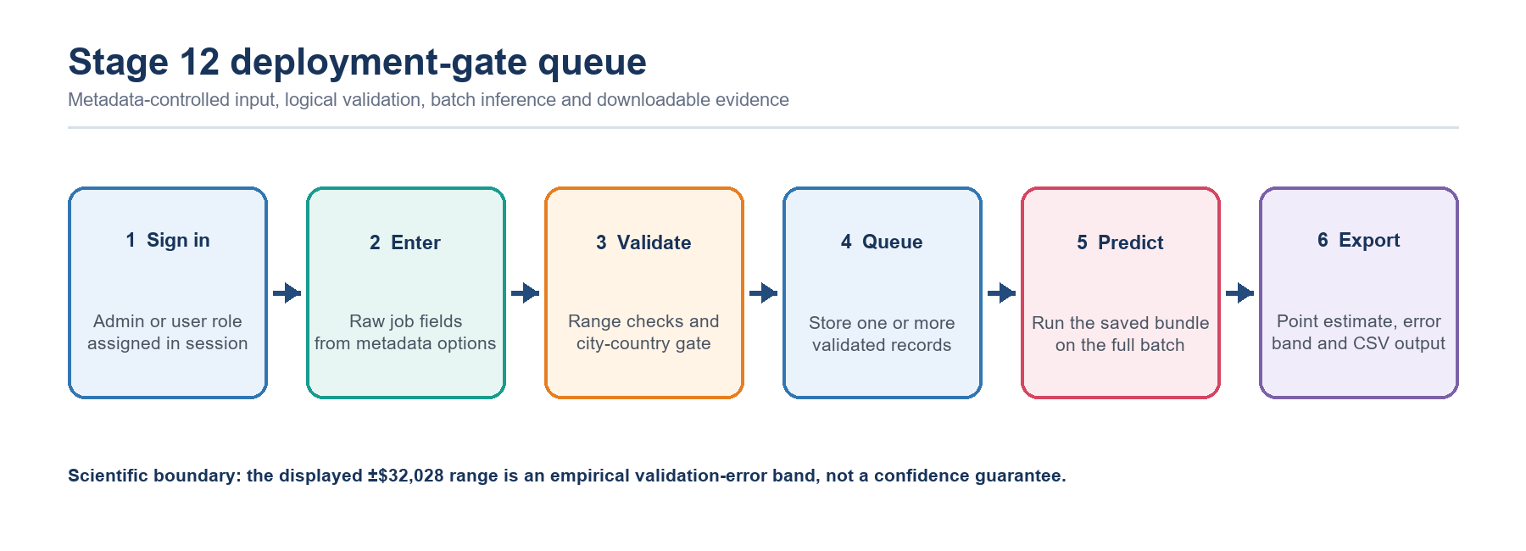
Figure 19. Stage 12 runtime flow: role-aware entry, logical validation, queue construction, batch inference and CSV export.
Input group | Fields | UI control | Validation source
Role | job_title, job_category | Select boxes | metadata.category_options
Experience | years_of_experience, education_required | Number input and select | Metadata ranges and ordered contract
Location | city, country, remote_work | Select boxes | Metadata plus configured city-country gate
Organization | company_size, industry | Select boxes | metadata.category_options
Market scores | demand_score, benefits_score_10 | Admin inputs; user medians | metadata.numeric_ranges
Skills | required_skills, skill_count | Multiselect and derived count | 93-token training vocabulary

1. Load metadata.json and model_bundle.joblib. If either artifact is missing, stop inference and ask the operator to rerun the pipeline.
2. Collect one raw job record from metadata-controlled widgets. For a standard user, fill demand_score and benefits_score_10 with the stored median values.
3. Normalize and deduplicate the selected skills, join them into required_skills and derive skill_count.
4. Apply the configured city-country consistency check before the record is accepted. Invalid configured pairs are rejected and never enter session state.
5. Append each valid record to st.session_state['prediction_queue']; repeat the form process to construct a multi-record batch.
6. When Predict Annual Salaries is selected, order every row by metadata.model_features and call the same saved bundle for the complete queue.
12.4. Queue controls, export and uncertainty communication:
Interface control | Application behavior | User-visible outcome
Add to Validation Queue | Validates one form submission and appends the accepted 13-field record | Queue count and table are updated
Predict Annual Salaries | Predicts all queued rows with the saved bundle | Batch table shows salary, lower bound and upper bound
Clear Queue | Resets prediction_queue in session state | The current scenario batch is removed
Download CSV | Maps queued inputs into the original 25-column source schema | Reusable data-collection file is downloaded
Last batch prediction detail | Retains the most recent result DataFrame in session state | Detailed results remain reviewable after prediction

CSV export procedure: the application creates one output row for every queued scenario, continues job_id from the readable maximum in the raw dataset, assigns the current posting year and month, copies available form values into their matching fields and leaves unsupported source fields blank. The exported column order matches the original 25-column dataset, which supports later labeling and controlled retraining.

Output field | Calculation or source | Interpretation
predicted_salary | model_bundle.predict(raw row in the 13-field order) | Estimated annual salary in USD
lower_bound | max(0, prediction − $32,028) | Lower practical validation-error bound
upper_bound | prediction + $32,028 | Upper practical validation-error bound
model label | metadata.model_name | Confirms which saved estimator produced the result
review evidence | Queue table, batch detail and downloadable CSV | Supports scenario review and reproducible handoff

Assessment: the interface update changes where deployment information is displayed, not how prediction is executed. The Best Model page remains focused on Stage 10 evaluation, while Stage 12 retains the validation boundary, multi-record queue, batch inference, practical error band and CSV export required by the current application.
Stage outcome: the dashboard is suitable for academic demonstration, controlled scenario comparison and collection of candidate records for later labeling. The ±$32,028 range is an empirical validation-error band rather than a confidence guarantee, and external verified market data is required before operational compensation decisions.

D – INSTALLATION & HOW TO RUN THE PROJECT
All commands in this section must be executed from the FPTCranes-PRJ2-main project root. Regenerate the offline artifacts before launching the dashboard whenever the data, features, preprocessing or model configuration changes.
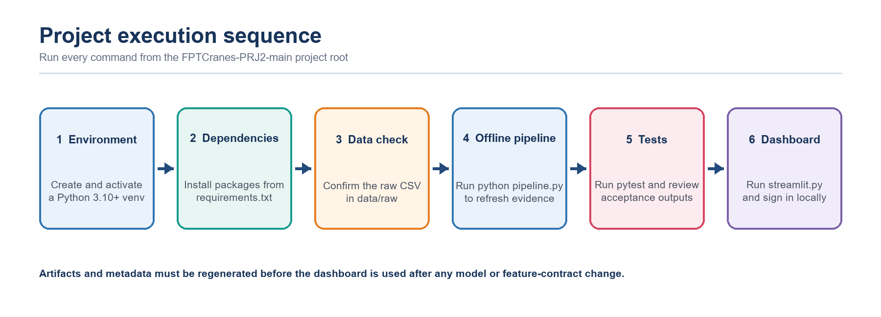
Figure 20. Recommended execution order from environment setup to the authenticated Streamlit dashboard.
D.1. Project folder structure:
FPTCranes-PRJ2-main/
├── data/raw/ai_jobs_market_2025_2026.csv
├── src/
│ ├── pipeline/ # 12-stage offline process
│ ├── training/ # preprocessing, temporal CV, ablation and tuning
│ ├── pages/ # Streamlit evidence and prediction pages
│ ├── components/ # authentication, navigation and shared UI
│ └── utils/ # artifact, insight and plotting helpers
├── outputs/
│ ├── 03_model_comparison/
│ ├── 04_best_model_and_feature_importance/
│ └── 05_salary_prediction/
├── artifacts/ # model bundle, metadata and contracts
├── config/project.yaml
├── tests/
├── pipeline.py # offline entry point
├── streamlit.py # dashboard entry point
└── requirements.txt

D.2. Prerequisites:
Requirement | Expected value | Verification
Python | 3.10 or later | python --version
Dependencies | pandas, numpy, matplotlib, scikit-learn, joblib, streamlit, pyyaml, pytest | python -m pip check
Raw data | data/raw/ai_jobs_market_2025_2026.csv | Confirm the file exists before training
Working directory | FPTCranes-PRJ2-main/ | pipeline.py and streamlit.py are visible

D.3. Step-by-step execution:
Step | Command | Expected result
1. Create environment | python -m venv .venv | Isolated Python environment created
2. Activate (Windows) | .venv\Scripts\activate | Virtual environment becomes active
2. Activate (macOS/Linux) | source .venv/bin/activate | Virtual environment becomes active
3. Install | python -m pip install -r requirements.txt | Required packages installed
4. Run pipeline | python pipeline.py | Stages 1–12 refresh outputs, artifacts and metadata
5. Run tests | python -m pytest -q | Automated project-contract checks complete
6. Launch dashboard | streamlit run streamlit.py | Local dashboard opens at http://localhost:8501

After launch, use the local demonstration account admin / AIJob2026! for the full evidence view or user / user123 for the simplified candidate view. Replace these credentials before any shared deployment.
D.4. Troubleshooting:
Error or symptom | Likely cause | Corrective action
Raw dataset not found | CSV is absent or the command is run from the wrong directory | Place the file in data/raw and run from the project root
ModuleNotFoundError | Dependencies are not installed in the active environment | Activate .venv and reinstall requirements.txt
Stage 09 outputs are missing | The offline pipeline has not completed | Run python pipeline.py and inspect the terminal log
Deployment artifacts are missing | model_bundle.joblib or metadata.json was not generated | Re-run the pipeline before Streamlit
Login fails | Credential mismatch or environment override | Check case, demo values and AI_JOB_USER / AI_JOB_PASSWORD
City-country validation error | The pair violates the deployment-gate map | Select a supported logical pair before adding to the queue

Operational rule: after changing the model, preprocessing or feature contract, do not reuse an older Streamlit session. Regenerate artifacts, restart the application and confirm bundle equivalence first.

E - CONCLUSION AND FUTURE DEVELOPMENT

F.1 | Data Basic Clean  A null-free dataset was not accepted at face value; logic and categorical corruption were audited.

Key item | Value
Raw dataset | 1,500 rows × 25 columns
Basic-clean output | 1,499 rows × 24 columns
Target | annual_salary_usd
Project period | Jan 2025 – Mar 2026
Final transformed matrix | 1,201 Train + 298 locked Test; 185 model features
Best locked-test model reviewed | Random Forest — MAE $15,054 | RMSE $29,993 | R² 0.801 | MedAE $4,440

Purpose of Stage 1:
- ingest the raw CSV and verify that the file can be parsed successfully. This stage intentionally avoids target-distribution analysis or feature profiling.
- understand the modeling unit, schema, feature types and the first descriptive distributions before deeper quality validation.
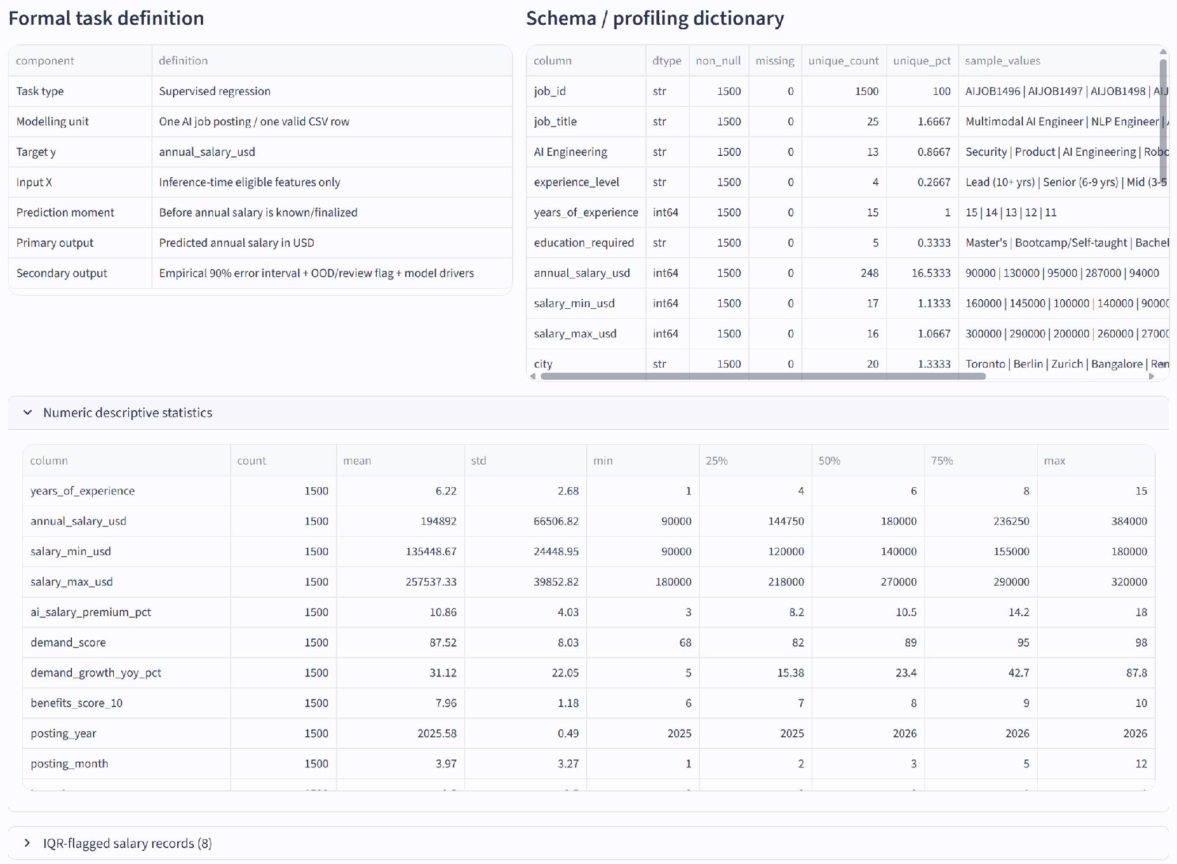
Figure 1. Stage 01 — Project Scope & Raw Data Ingestion.
Purpose of Stage 2:
- evaluate completeness, validity, consistency, duplication and numeric outlier signals on the raw dataset before any cleaning or removal.
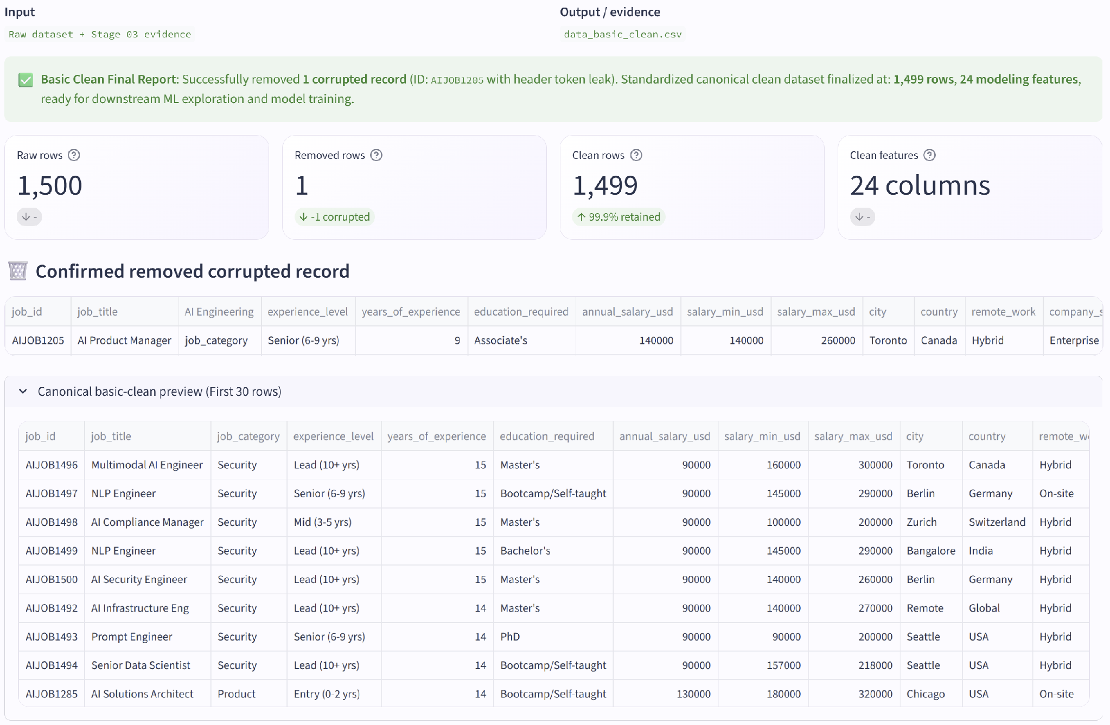
Figure 2. Stage 02 — Basic Clean.

Purpose of Stage 3: investigate semantic contradictions, target-adjacent salary fields, and redundant feature families before selecting the model-serving feature set.
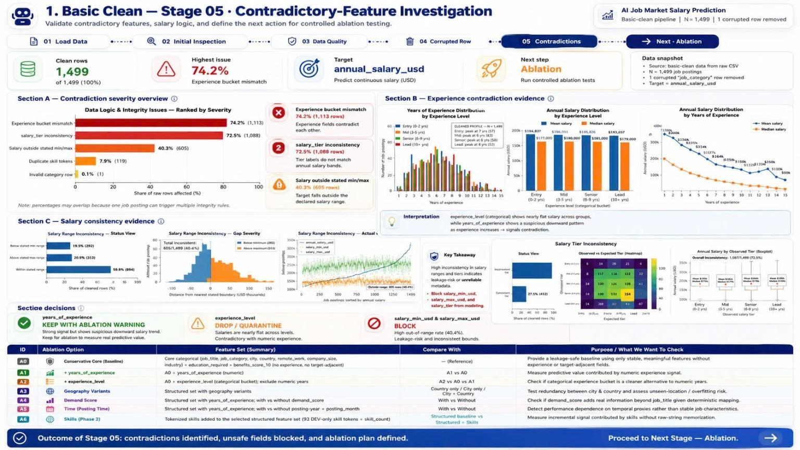
Figure 3. Stage 03 — Contradictory-Feature Investigation.
Conclusion – Clean Data Structural cleanliness alone would have been misleading. The cleaned output is suitable for controlled modeling only after blocking inconsistent target-adjacent fields and explicitly treating experience semantics as a synthetic-risk warning.

Clean Data | Fields
Primary keep (13) | job_title, job_category, years_of_experience, education_required, city, country, remote_work, company_size, industry, demand_score, benefits_score_10, required_skills, skill_count
Blocked / removed (12) | job_id, salary_min_usd, salary_max_usd, salary_tier, experience_level (from primary set), posting_year, posting_month, is_senior, is_remote_friendly, is_llm_role, ai_salary_premium_pct, demand_growth_yoy_pct

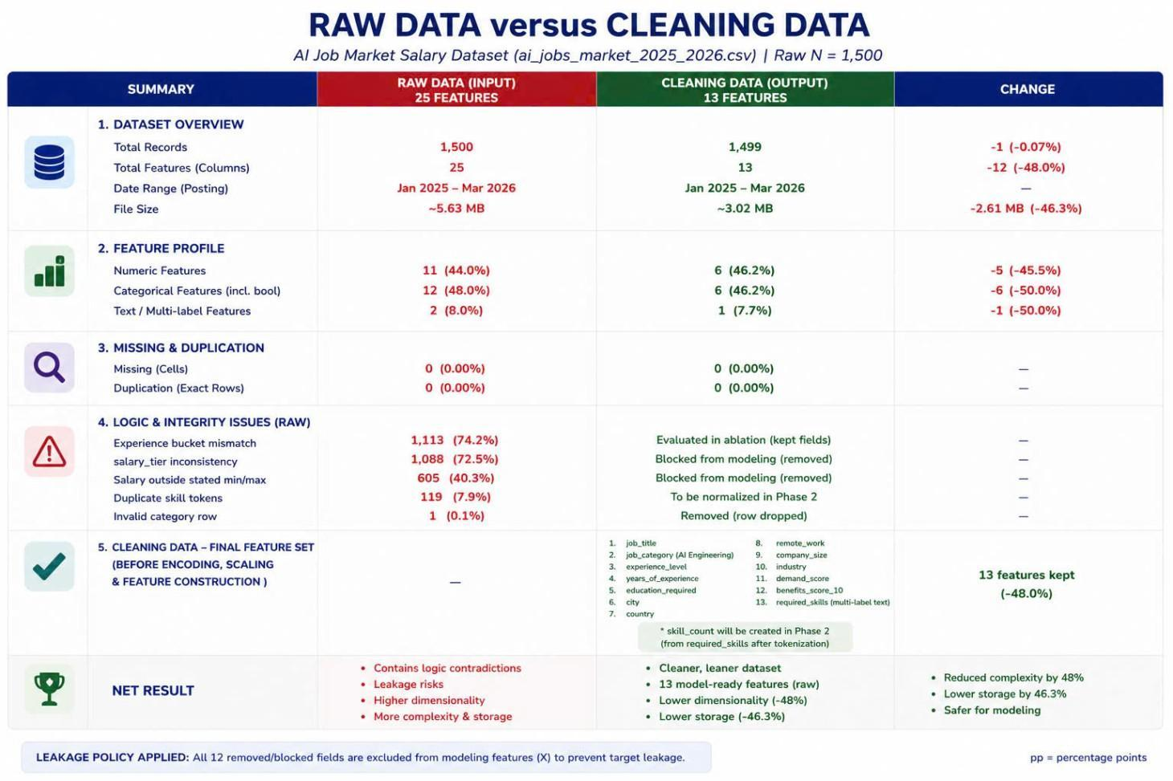
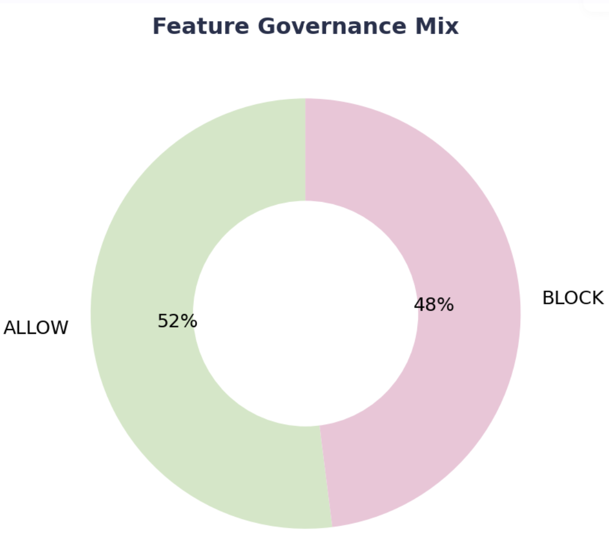

F.2 | Data Ready for Machine Learning  Leakage gate, temporal split, TRAIN-only encoding/scaling, multi-hot skills and skill_count.

Purpose of Stage 4:
- quantify the incremental predictive value of disputed or optional feature families before locking the primary model feature set.
- fit the preprocessing objects on Train only, transform the analytical feature matrix, and review encoded-feature and skill correlations before final modeling.

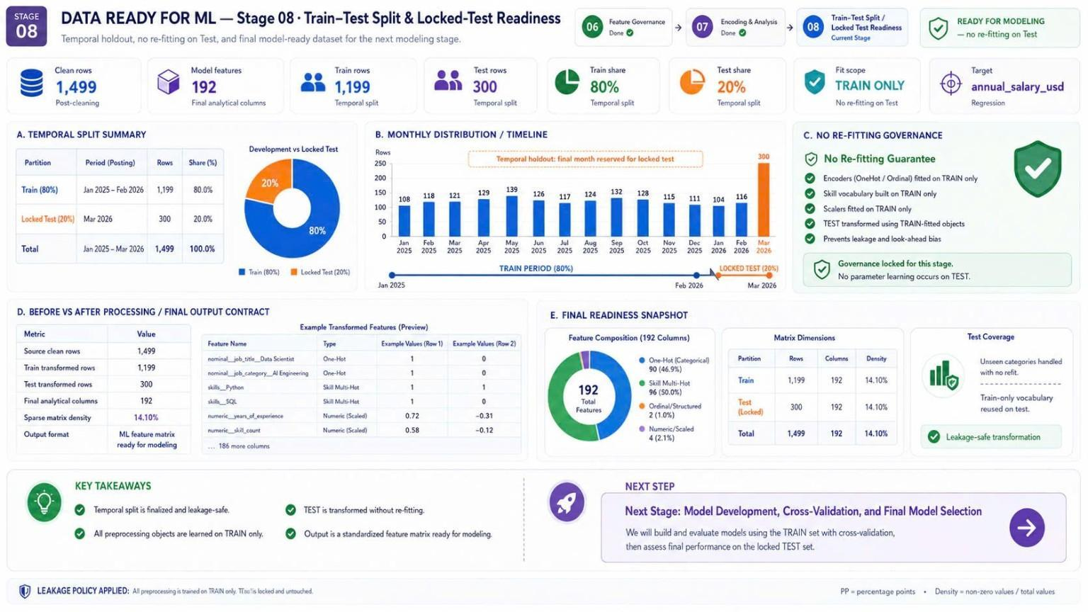
Figure 4. Stage 04 — Train-Test Split & Locked-Test Readiness.

Purpose of Stage 5:
- finalize the temporal holdout, guarantee no re-fitting on Test, and generate the model-ready matrices used by the next modeling stage.
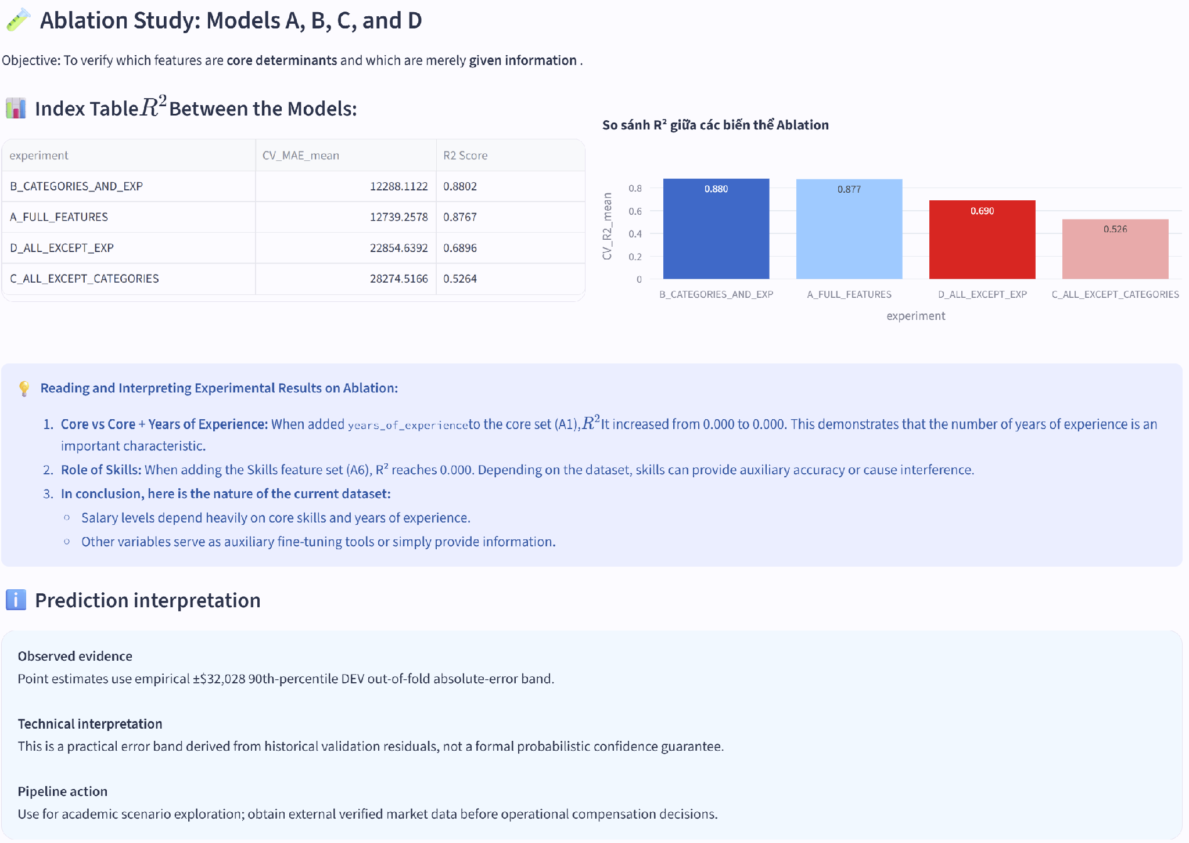
Figure 5. Stage 05 — Ablation Analysis & Feature Governance.
Conclusion – Data ready for ML The encoded dataset is ready for modeling with 2 numeric columns. The strongest TRAIN-only encoded correlation is nominal__job_category_AI Engineering (r=+0.81) and years_of_experience (r=-0.72) ; this is diagnostic association, not causal evidence.

Policy group | Fields
Primary keep (2) | job_title, job_category, years_of_experience
Blocked / removed (22+1) | job_id, salary_min_usd, salary_max_usd, salary_tier, experience_level (from primary set), posting_year, posting_month, is_senior, is_remote_friendly, is_llm_role, ai_salary_premium_pct, demand_growth_yoy_pct  job_title, education_required, city, country, remote_work, company_size, industry, demand_score, benefits_score_10, required_skills, skill_count

F.3 | AI Job Market Segmentation  Unsupervised application to explore structural groupings without using salary as a clustering target
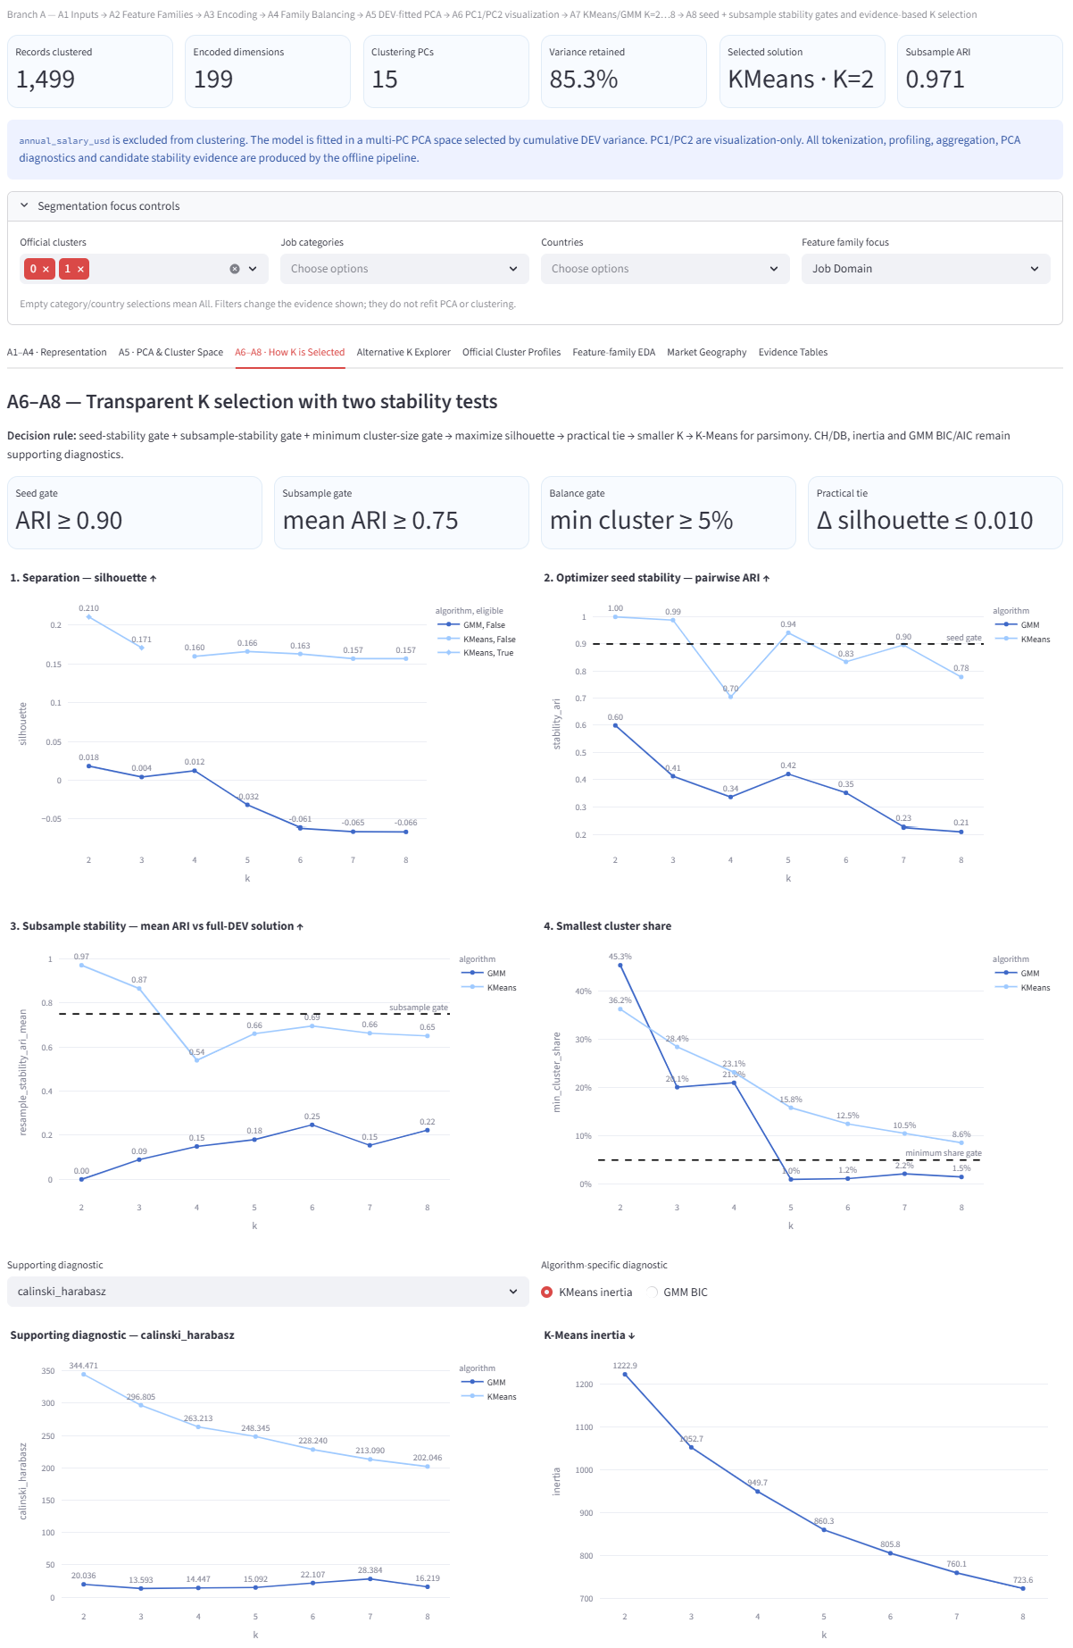
Figure 6. Branch A — Selected K = 2.
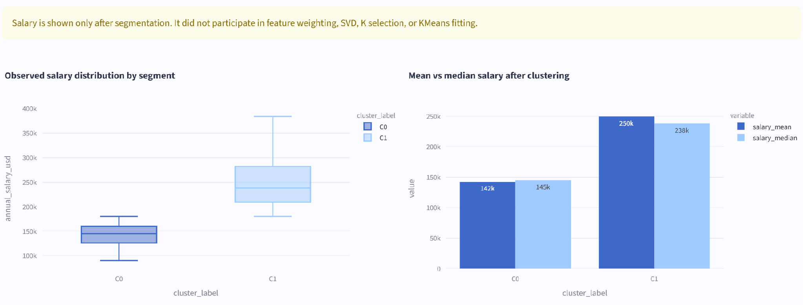
Figure 7. Branch A — Observed Salary Distribution by Segment.
F.4 | Model Comparison  Leakage-safe comparison on identical expanding monthly validation folds.

Purpose of Stage 9: compare the approved regression families under the same out-of-time validation design and select the model family before opening the March 2026 locked test.
Random Forest  Selected family | $12,594  Mean CV MAE | 0.878  Mean CV R² | 5  Temporal folds

Comparison evidence:
Rank | Candidate | Mean MAE | MAE SD | Mean R² | Decision
1 | Random Forest | $12,594 | $2,887 | 0.878 | Selected
2 | Gradient Boosting | $14,408 | $1,498 | 0.853 | Strong challenger
3 | Ridge Regression | $25,489 | $3,220 | 0.718 | Not selected
4 | Linear Regression | $28,827 | $3,380 | 0.658 | Not selected
5 | Dummy Median | $54,177 | $5,071 | −0.058 | Reference floor

Figure 4. Mean temporal-CV MAE across the approved candidates; lower values are better.
Evaluation: Random Forest reduces mean MAE by 12.6% relative to Gradient Boosting and by 76.8% relative to the Dummy Median floor. The same five folds and the same TRAIN-only preprocessing are used for every candidate, so the comparison isolates model-family performance rather than split or preprocessing differences.
Conclusion – Model comparison Random Forest provides the strongest aggregate out-of-time accuracy and proceeds to bounded tuning. The selection is made without consulting the locked test; runtime is acceptable for all serious candidates and is therefore not the deciding factor.

F.5 | Best Model Selection and Feature Importance Review  One-time locked-test evaluation with residual-tail and feature-reliance diagnostics.

Random Forest  Best model | $15,005  Locked MAE | $29,819  Locked RMSE | 0.803  Locked R² | $4,354  Locked MedAE

Purpose of Stage 10: tune the selected family inside the development period, evaluate the frozen configuration once on 298 future records and determine whether its errors and reliance evidence support the intended academic use.
Figure 5. Actual versus predicted annual salary for the 298 locked-test records.

Figure 6. Encoded impurity importance and raw-feature permutation importance show complementary forms of model reliance.
Evaluation question | Evidence | Assessment
Does the model generalize out of time? | $15,005 MAE and 0.803 R²; MAE is 20.8% above tuning CV. | Predictive value remains, with measurable temporal degradation.
Is the error uniform? | $4,354 MedAE versus $29,819 RMSE. | Most errors are modest, but a smaller tail of large misses drives RMSE.
What drives the model? | job_category and years_of_experience dominate both reliance diagnostics. | Interpret as model behavior, not causality or a salary rule.
Does high importance mean high accuracy? | AI Engineering: 156 records and MAE ≈ $26,319. | No. A heterogeneous, influential category can still contain the largest errors.
How is uncertainty communicated? | Empirical validation-error half-width: ±$32,028. | Useful warning band, not a formal confidence interval.

Conclusion – Best model and feature importance The frozen Random Forest is suitable for academic benchmarking and controlled scenario exploration. Its typical error is much smaller than its tail-sensitive error, and the AI Engineering result demonstrates that importance measures reliance—not reliability, balance or causal effect.

F.6 | AI Market Job Salary Prediction  One saved pipeline, a metadata-driven Streamlit contract and an explicit practical error band.
(PIC = Hiển)
298  Locked-test rows | $197,695  Mean prediction | $194,612  Median prediction | ±$32,028  Practical half-width

Purpose of Stages 11 and 12: serve the exact preprocessing-plus-model bundle evaluated offline, validate the ordered 13-field input contract and return each point estimate with an empirical error band and scientific-use warning.
Figure 7. Saved-bundle serving contract from raw inputs to the point estimate and practical error band.
Contract item | Implementation evidence | Why it matters
Single fitted bundle | Preprocessor and Random Forest serialized together | Reduces training-serving skew
Metadata-driven form | 13 ordered raw fields, categories, ranges and 93 skills | Keeps the interface aligned with training
Artifact verification | Reloaded predictions match; max_abs_diff = 0 | Confirms serialization equivalence
Practical bounds | max(0, prediction − $32,028) to prediction + $32,028 | Shows observed validation uncertainty

Figure 8. Role-aware entry, logical validation, queue construction, batch inference and CSV export.
Representative locked-test predictions:
Job title | Category | Location | Actual | Predicted | Absolute error
AI Compliance Manager | Security | Zurich, Switzerland | $90,000 | $91,846 | $1,846
AI Solutions Architect | AI Engineering | Boston, USA | $287,000 | $258,447 | $28,553
AI Solutions Architect | AI Engineering | Toronto, Canada | $360,000 | $264,284 | $95,716
ML Engineer | AI Engineering | Paris, France | $360,000 | $194,552 | $165,448

Interpretation: the examples deliberately show both small and large errors. Two AI Engineering cases exceed the ±$32,028 practical band, reinforcing that the band summarizes held-out absolute error rather than guaranteeing coverage for every record.
Future development priorities:
Priority | Next development step | Acceptance evidence
External validity | Evaluate later, independently sourced job postings and preserve temporal ordering. | Report MAE, RMSE and R² by month, category and country before operational use.
Uncertainty quality | Replace the fixed global band with calibrated, subgroup-aware prediction intervals. | Publish empirical coverage and interval width on untouched data.
Deployment governance | Add managed secrets, artifact versioning, audit logs and drift/retraining triggers. | Produce traceable releases and reviewed alerts rather than silent model changes.

Conclusion – Salary prediction The dashboard implements the same metadata-controlled inference contract as the offline pipeline, including logical input validation, queued batch prediction, downloadable evidence and uncertainty communication. It is appropriate for academic demonstration, but external validation, monitoring, stronger authentication and broader market data are required before operational compensation decisions.

F - REFERENCES
- eBook
- eBook
- eBook
- eBook

G - TASK ASSIGNMENT TABLE

No. | Main task | Student name | Completion - %
1 | - | Gia Bảo | -
2 | Stage 1, 3, Branch A & Overall Pipeline Design | Nguyễn Kim Ngân | 100%
3 | Foundation - Stage 2, 4, 5 & Video | Hoàng Đức Duy | 100%
4 | Branch B – B1, B4, B5 & Structure of Source Code | Huỳnh Minh | 100%
5 | Branch B – B2, B3, B6 & Enhancement for New Dataset | Tạ Gia Hiển | 100%

